User Registration for the Reassigned Numbers Database

User Guide

Version 1.1
April 5, 2021

Change History
Date | Revision | Change
03/22/2021 | 1.0 | Initial User Guide
04/05/2021 | 1.1 | Section 3 and 5 regarding Authorizer

Table of Contents
1.0. Introduction 3
1.1. Purpose 3
1.2. Overview 3
1.3. System Settings 4
1.4. Assistance 4
2.0. Initial Registration 4
Step 1: Identify Type of User 4
Step 2: Identify Primary Contact 5
Step 3: Gather Required Information 5
Step 4: Contact RND Customer Support 5
Step 5: Complete Online Registration Form 6
Step 6: RND Customer Support Reviews Registration Request 12
Step 7: Login 14
3.0. Adding Additional Users to a Company 21
4.0. Adding Client Companies – Service Provider Agents 25
5.0 Notifications 31
6.0 Exception Messages 33
7.0 Acronym List 35

1.0. Introduction

1.1. Purpose
This document provides instructions for registering as a Reassigned Numbers Database (RND) user.

1.2. Overview
The RND system securely houses all permanently disconnected United States (US) geographic and toll-free numbers and the most recent permanent disconnection of each of those numbers. RND supports submitting permanently disconnected telephone numbers and querying the RND. To gain access to the RND system, the user must be registered.
The RND website can be reached at www.reassigned.us for more information (Figure 1.1).

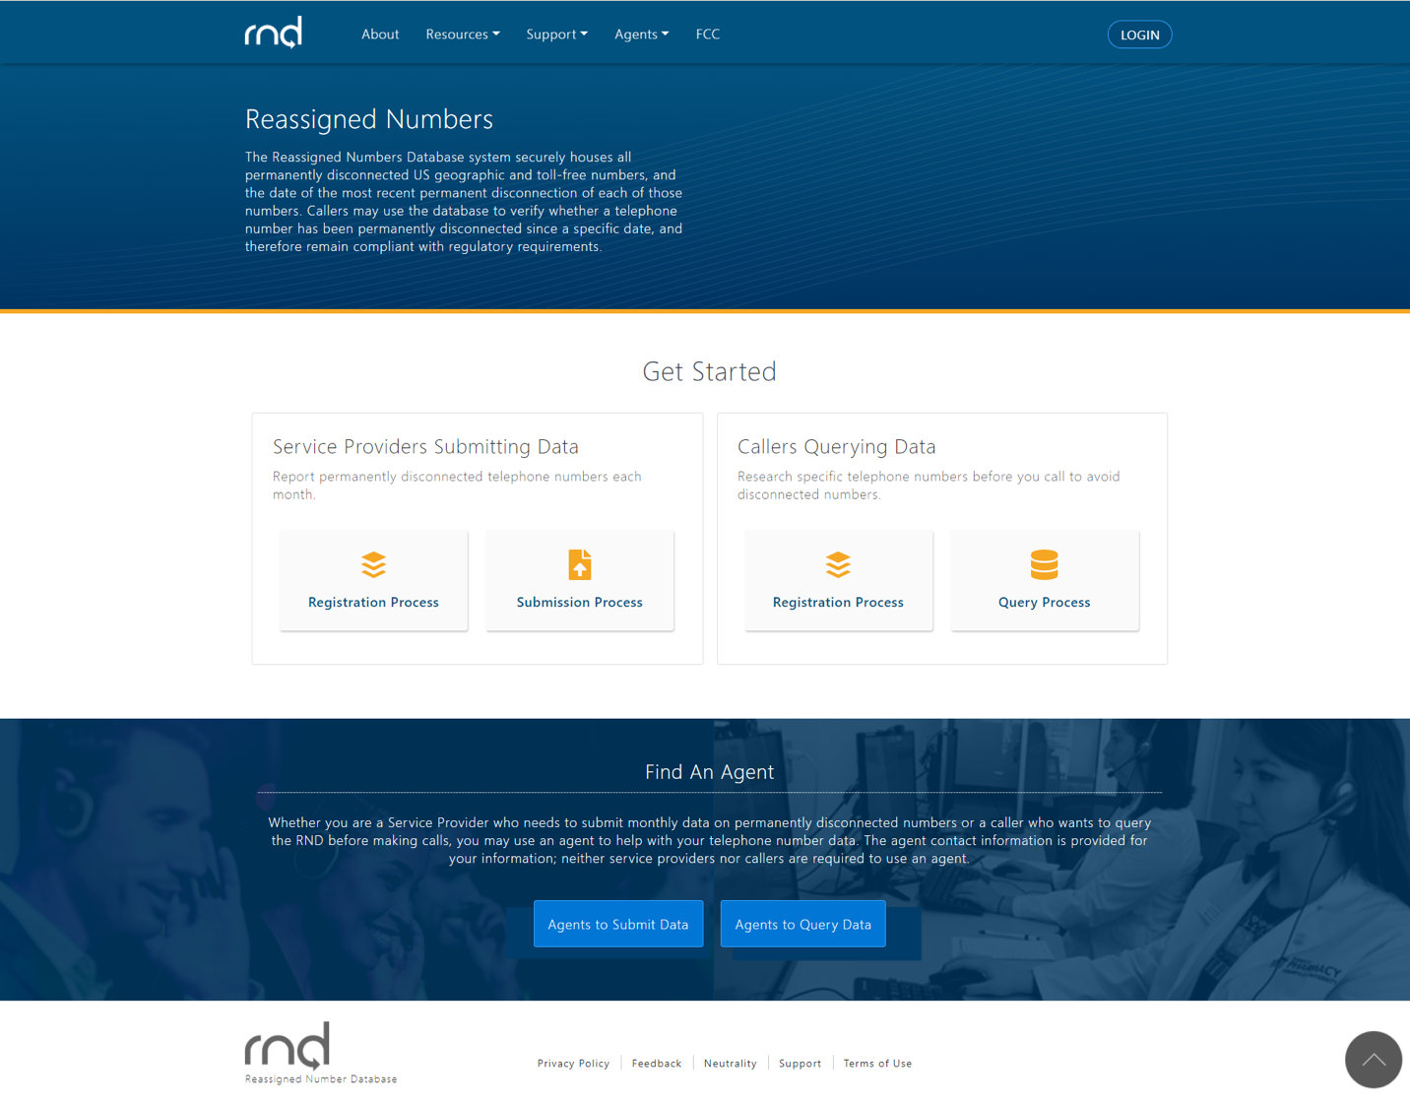
Figure 1.1

These are the steps for user registration:
- Identify the type of user.
- Identify the Primary Contact for the user’s company.
- Gather the required information for registration.
- Contact RND Customer Support to receive the online registration link.
- Complete the online registration form.
- RND Administrator will review the registration request.
- Login.

1.3. System Settings
The RND uses the following standard date and time format for displaying and downloading data: MM/DD/YYYY HH:MM:SS in Eastern Time. Example: 02/08/2021 14:35:22.
When entering or editing data in the RND, a red asterisk (*) will appear next to required fields.

1.4. Assistance
Questions or issues on the RND may be directed to RND Customer Support at 833-763-2366 or support@reassigned.us

2.0. Initial Registration

Step 1: Identify Type of User
The RND will be used by two main groups of users, those who submit data and those who query the data.
Submit Data:
- Service Provider (SP) – A user who is a representative of an entity authorized to submit monthly permanently disconnected number reports and query their own data stored in the RND (e.g., telecommunications carrier, interconnected VoIP service provider or other entity that received number resources from NANPA).
- Service Provider Agent (SPA) – A consultant authorized by a Service Provider to submit monthly permanently disconnected number reports and query their own data in the RND on the Service Provider’s behalf.
Query Data:
- Callers – A user who is authorized to query RND data to determine whether a telephone number has been permanently disconnected, and therefore is eligible to have been reassigned before calling the consumer (e.g., Pharmacies, Doctor’s offices, Banks, Collection Agencies, etc.)
- Caller Agents – A user who has been authorized on behalf of another Caller that queries the RND to determine whether a telephone number has been permanently disconnected, and therefore, is eligible to have been reassigned before calling the consumer.

Initially, registration applications will only be accepted for the Service Provider and Service Provider Agent user types.

Step 2: Identify Primary Contact
For each company, a Primary Contact is required to complete the registration first. Once the Primary Contact is registered, the Primary Contact may invite additional users to their company. Each company can only have one Primary Contact. If the company is either a Service Provider Agent or Caller Agent, the fully registered Primary Contact will also be able to add clients.

Step 3: Gather Required Information
In order to register, the applicant will need following information:

- Primary Contact - This will be the Primary Contact for the Company ID and will be able to authorize and invite other users to their company in the RND. The following information will be required for the Primary Contact registration and to establish the Company ID in the RND:
  - Name
  - Title
  - Email Address
  - Work Telephone Number
  - User Type (e.g., Service Provider, Service Provider Agent, etc.)
- Authorizer Information – the person authorizing you to register in the RND. The authorizer must be someone in your company, other than yourself.
  - Name
  - Title
  - Work Telephone Number
  - Company Name
  - Email Address

Step 4: Contact RND Customer Support
In order to request login credentials to the RND, the Primary Contact shall send an email to support@reassigned.us indicating the following:
Confirmation they will be serve as the Primary Contact for their company, responsible for inviting additional users from their company to access the RND.
Identification registration as one of the following user types:
- Service Provider
- Service Provider Agent
Service Provider Agents have Client companies and must attach a Letter of Authorization (LOA) to their email requesting their registration for each Client that the SPA intends to add to their profile in the RND.
The LOA must contain the following:
- The LOA must be on the Client SP’s company letterhead.
- The following must be included in the LOA:
  - A statement that the SPA is authorized to submit permanently disconnected telephone numbers reports or updates to the RND on behalf of the Client SP company.
  - The Company Identifier for the Client SP company for which the SPA is acting. Please note: The SP or SPA can designate, otherwise the RND will assign and company identifier. The Company Identifier must consist of a minimum of 3 and maximum of 10 characters (alpha and numeric accepted).
  - The LOA must be signed by the Client SP company.
  - The LOA must be dated.
  - The LOA must include the Point of Contact for the Client company information in the RND including the following: Name, Title, Email, Work Phone.
RND Customer Support will send an email back to the Primary Contact. The email will contain a link to an online registration form which is only valid for the Primary Contact and must be used within 7 calendar days (Figure 2.1).
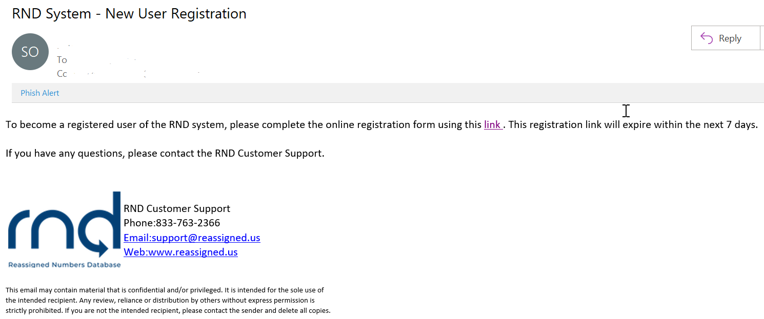
Figure 2.1

Step 5: Complete Online Registration Form
After the applicant selects the link within the New User Registration email, the applicant will be directed to the RND website and information will be collected in the online registration form.

- User Information (Figure 2.2)
  - Username – This will be used by the Primary Contact to login to the system:
    - Minimum of 6 characters, maximum of 25 characters.
    - Letters and numbers are accepted.
    - Special characters including exclamation point “!”, pound “#”, dollar “$”, caret “^”, asterisk “*”, underscore “_” , hyphen “-“, period “.” and “`” grave accent (backtick) are accepted.
    - Must be unique in the system.
  - Name – including First Name, Middle Initial, Last Name.
  - Email – This will be set by the system based on information provided to RND Customer Support at the beginning of the registration process.
  - Work Phone including optional Extension and Text-Enabled setting.
  - Secondary Phone and optional Text-Enabled setting.

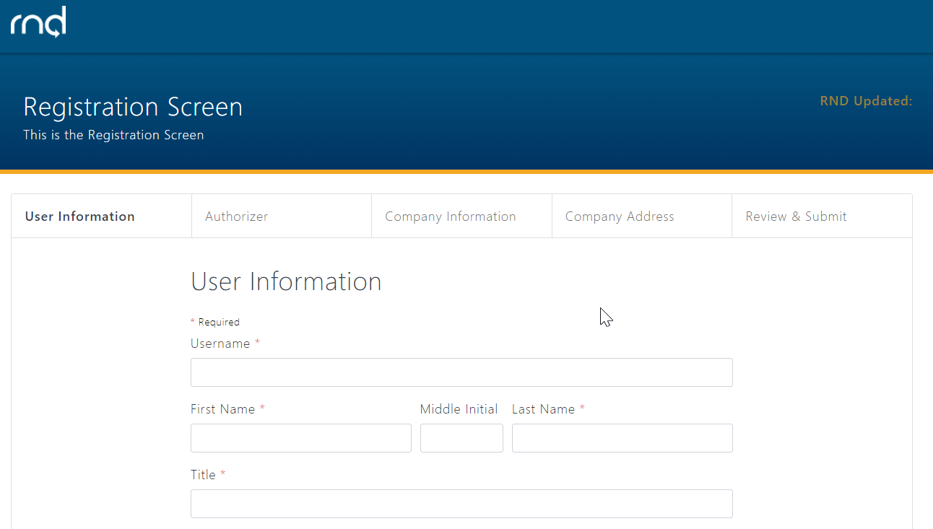
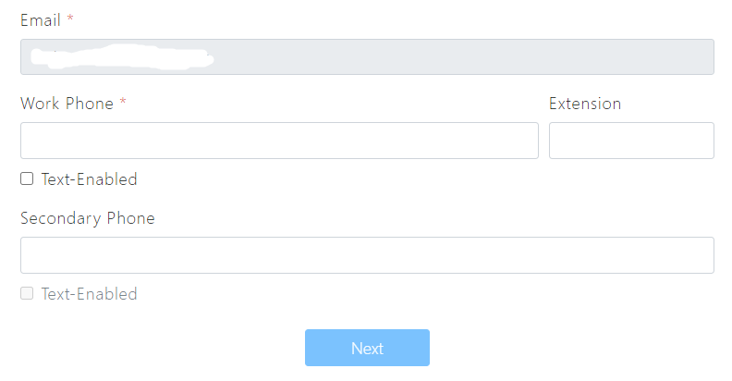
Figure 2.2

Please note that if the applicant fails to enter any of the required fields or enters them in an incorrect format, the Next button will not be highlighted and the applicant will not be allowed to proceed to the next step in the registration process.

- Authorizer - this information will be collected as additional information on use of the RND for the company (Figure 2.3). The authorizer must be someone in your company, other than yourself.
  - Name
  - Title
  - Telephone Number and optional Extension
  - Company Name
  - Email

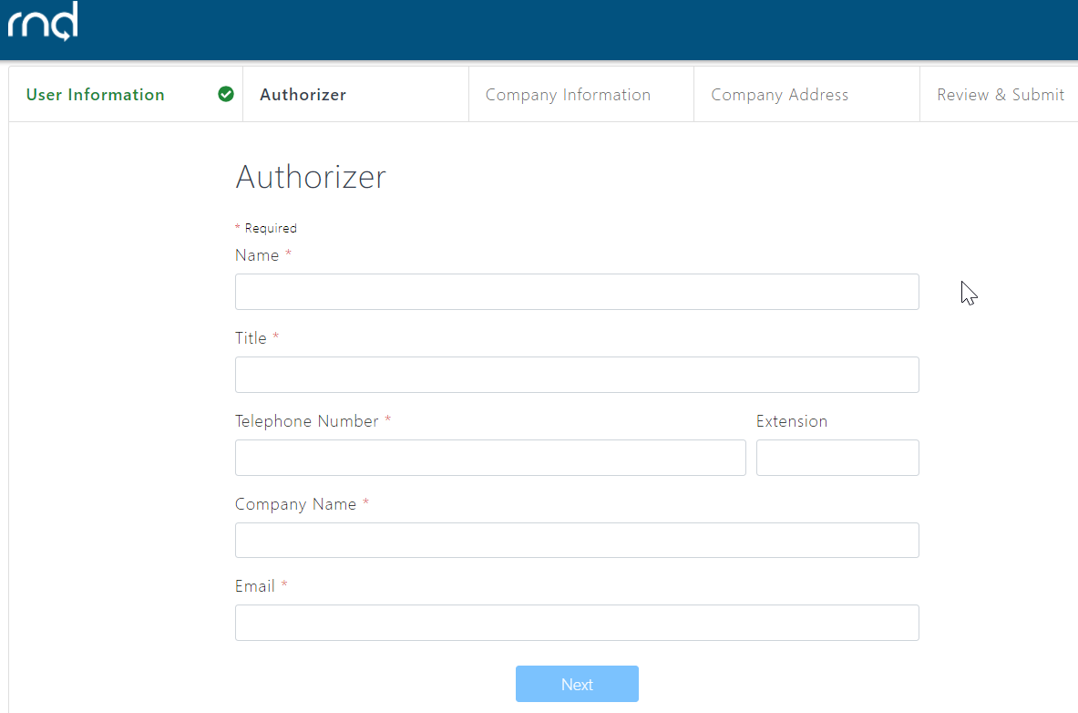
Figure 2.3

- Company Information (Figure 2.4)
  - Company Identifier
    - SP / SPA – Enter a desired value or leave blank and select the Use System-Generated Company ID checkbox to have one automatically assigned by the system:
      - Minimum 3 characters, maximum 10 characters.
      - Alphabet and numbers.
    - Caller / Caller Agent – Will be assigned by the system.
  - Company Name
  - Company Type – Will be set by system based on information provided to RND Customer Support at the beginning of the registration process.

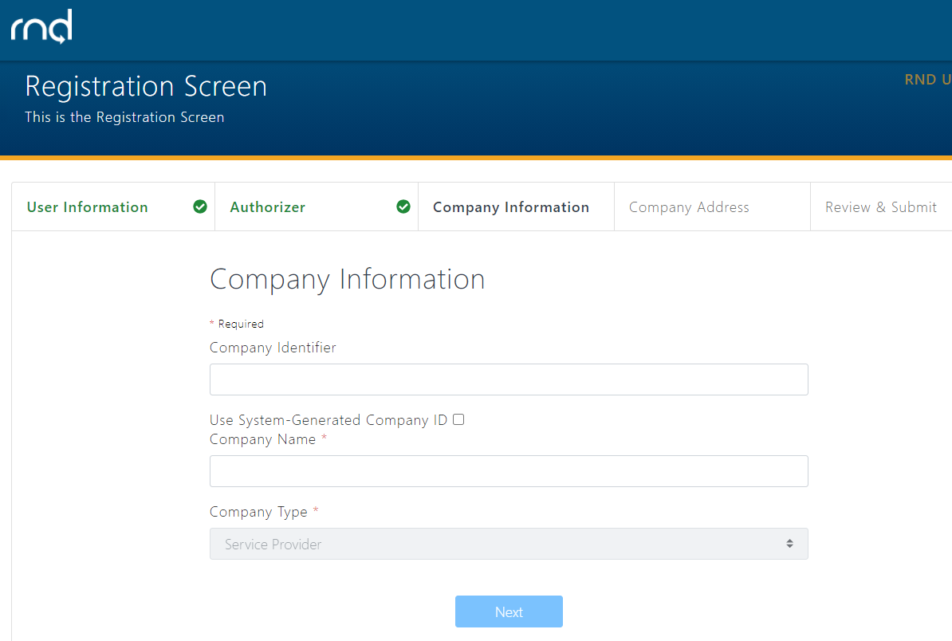
Figure 2.4

- Company Address (Figure 2.5)
  - Street Address
  - City
  - State / Territory
  - Zip Code
  - Country

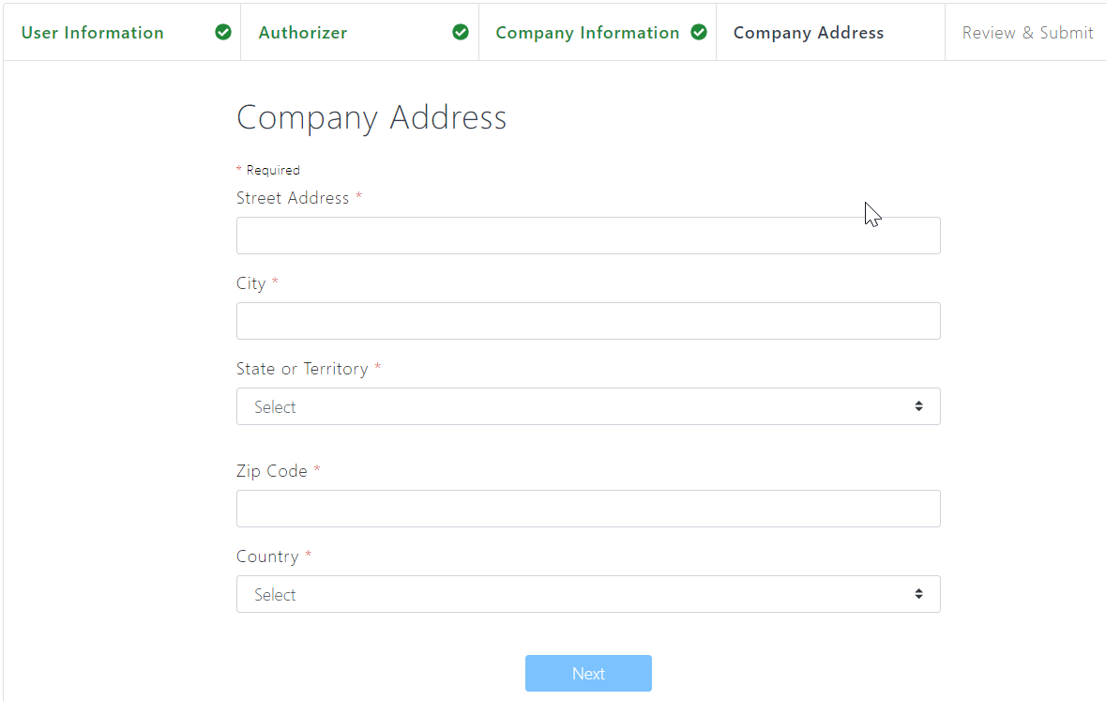
Figure 2.5

- Review & Submit
  - Review information (Figure 2.6).
  - Click Edit for any updates to the information.

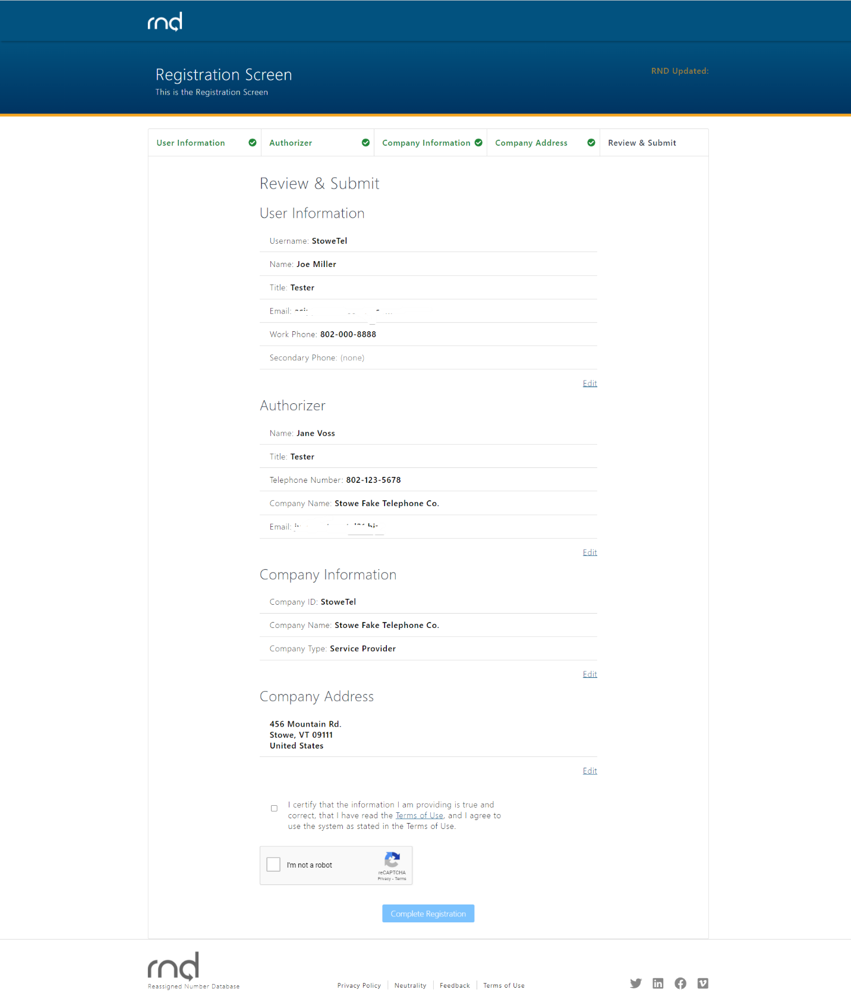
Figure 2.6

After selecting Complete Registration, the applicant will be notified of the successful submission (Figure 2.7).

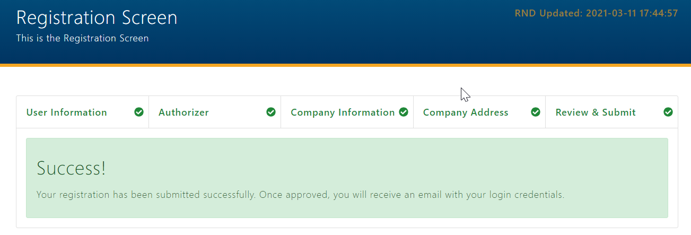
Figure 2.7

The applicant will also be sent an email notification (Figure 2.8).

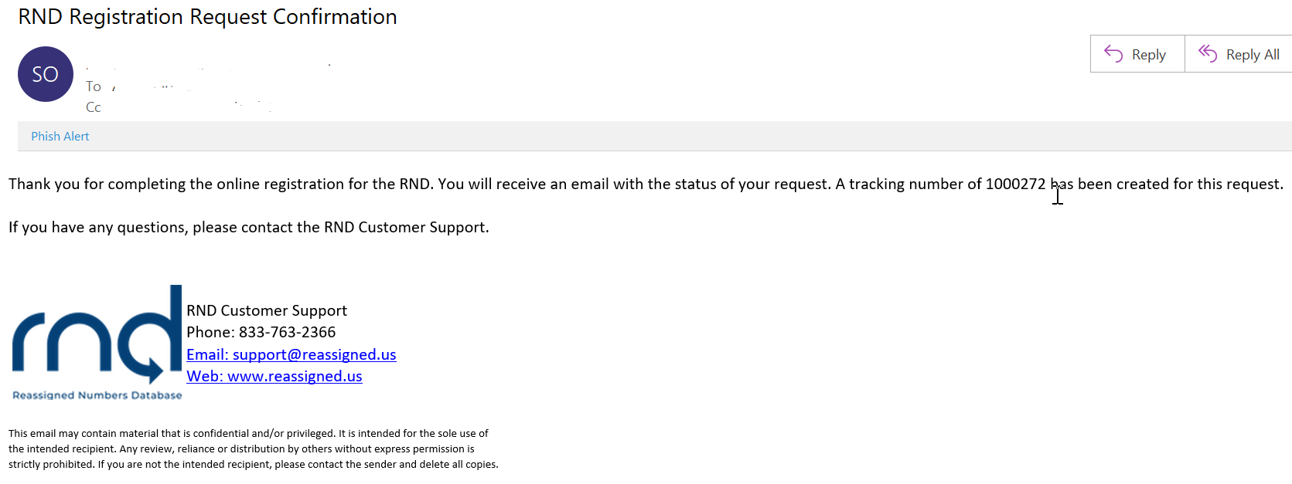
Figure 2.8

Step 6: RND Customer Support Reviews Registration Request
RND Customer Support will review the submitted registration request by the Primary Contact within five business days. If approved, the Primary Contact will receive an email confirmation with information to login to the RND and a temporary password which is valid for 7 calendar days (Figure 2.9).

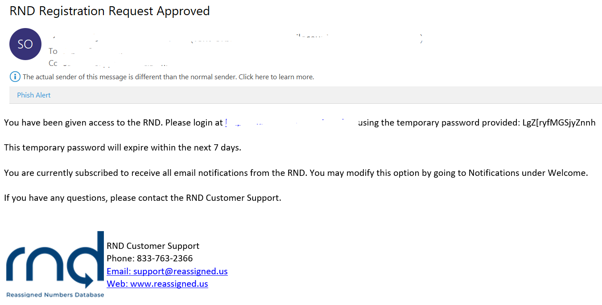
Figure 2.9

If denied, the Primary Contact will be sent an email with the reason for denial and may reach out to RND Customer Support with questions (Figure 2.10).

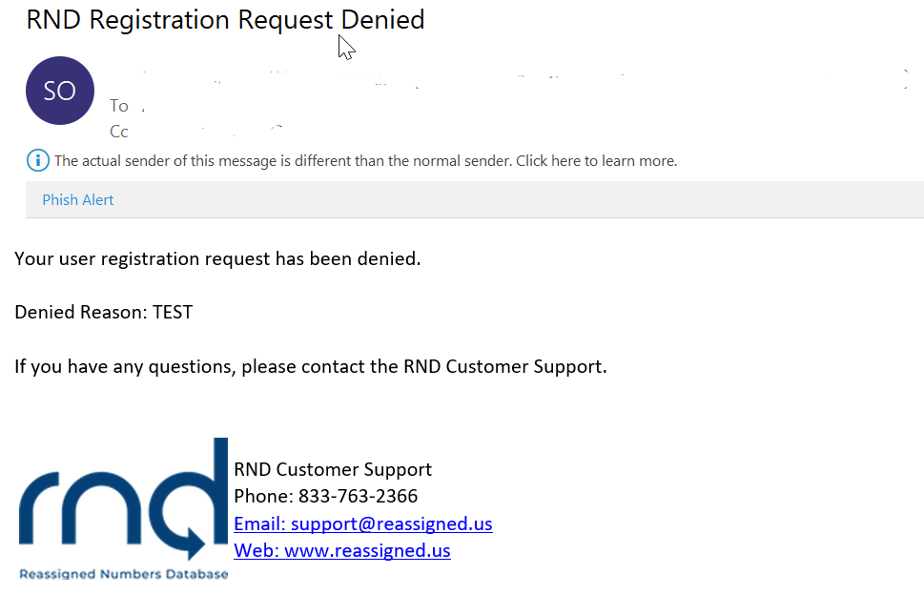
Figure 2.10

Step 7: Login
After selecting the link in the approval email, the user will be directed to the Login to RND screen (Figure 2.11).

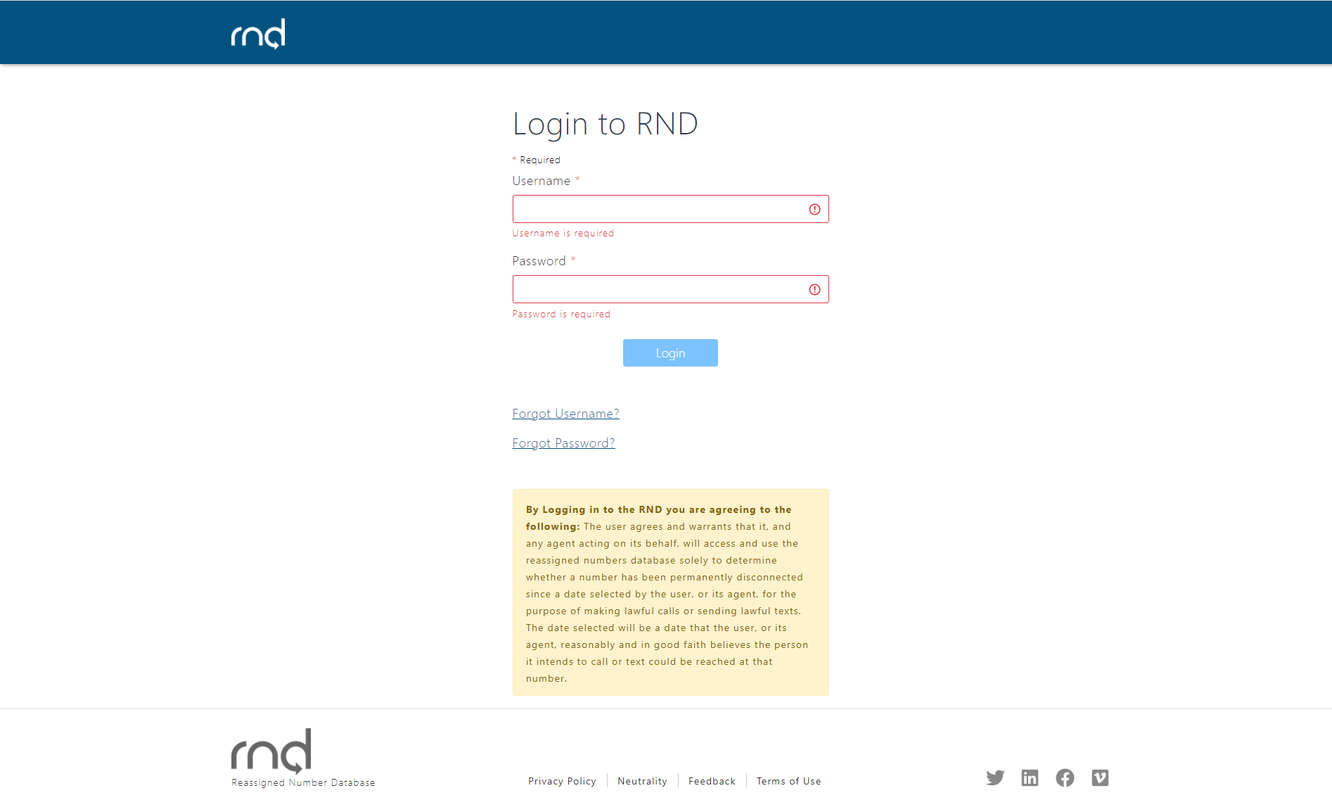
Figure 2.11

After entering the Username and temporary password sent in the Approval email, the Login button will be highlighted (Figure 2.12).

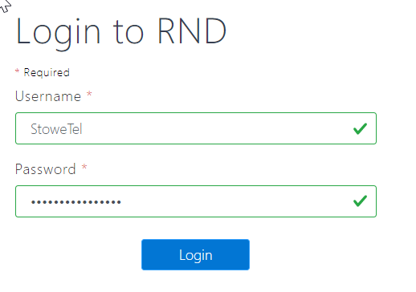
Figure 2.12

After selecting the Login button, the user will then be prompted to change the temporary password sent in the Approval email to a new password which contains at least 16 characters with at least 1 upper case letter and 1 lower case letter (Figure 2.13).

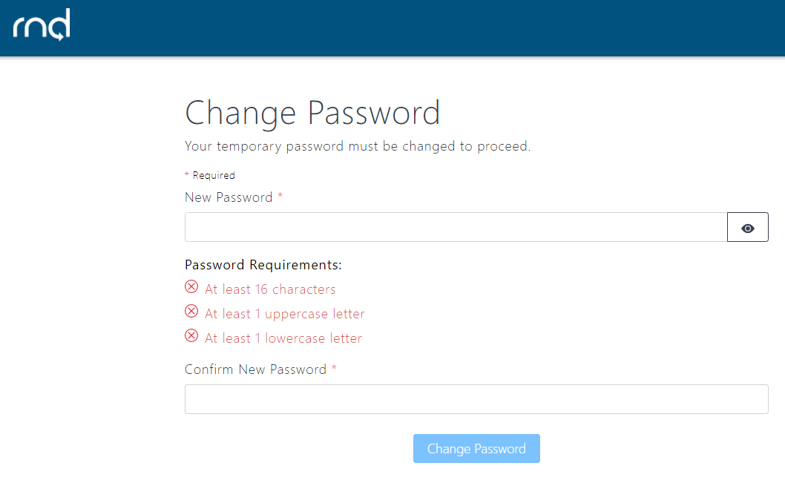
Figure 2.13

The RNDA recommends using a robust password such as a passphrase with combination of uppercase and lowercase letters, symbols and numbers. Passwords will expire every 180 days and the user will be required to set a new password prior to 180 days. If your password expires, please contact RND Customer Support.

After changing the password, the user will be prompted to perform Multi-Factor Verification (MFA) Set-Up (Figure 2.14).

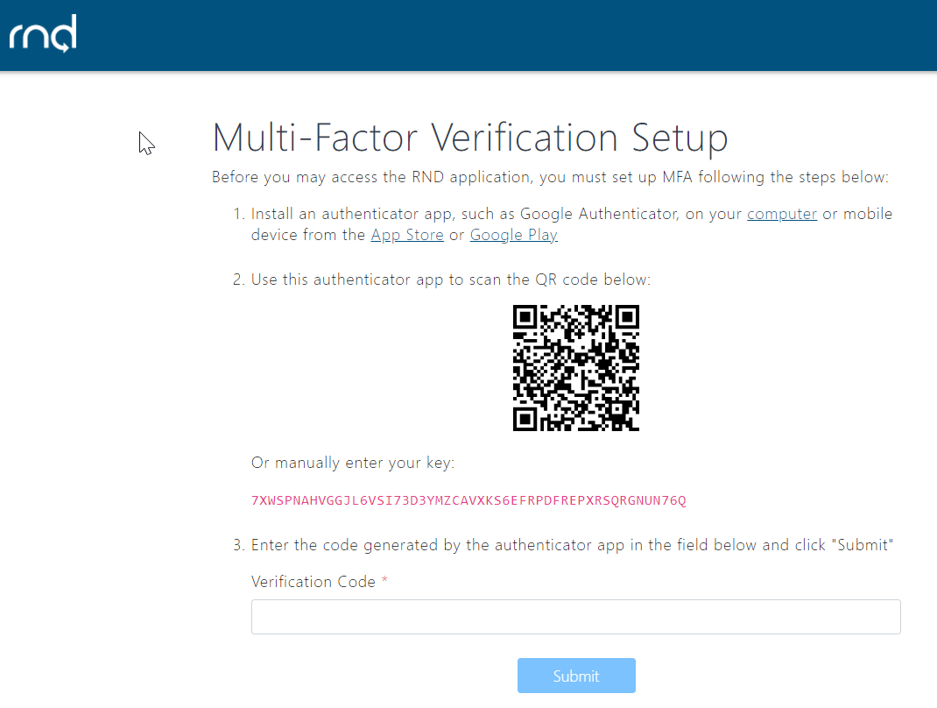
Figure 2.14

To set up MFA:

- Install an authenticator app, such as Google Authenticator, on your computer or mobile device from the App Store or Google Play. When the user selects the computer link, the user’s internet browser will redirect the user to add the authenticator to the user’s browser (Figure 2.15).

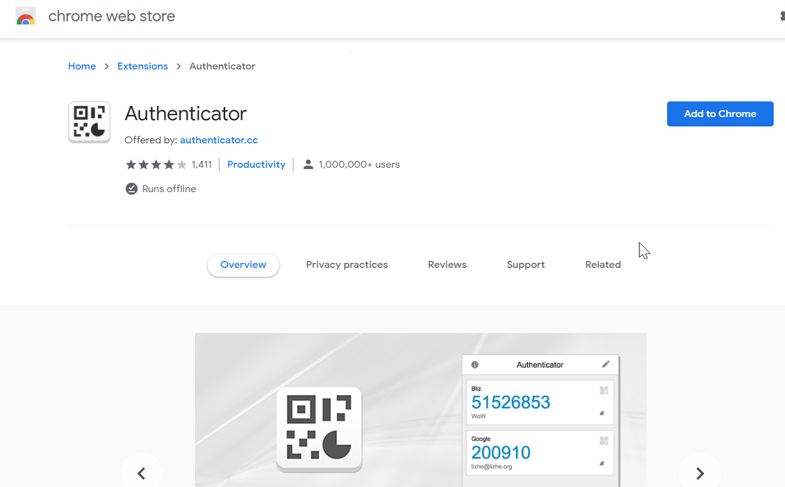
Figure 2.15

After adding the authenticator, an icon will be added to the user’s browser (Figure 2.16).

Figure 2.16

After selecting the authenticator icon, the user will select an icon within the authenticator to Scan QR Code (Figure 2.17).

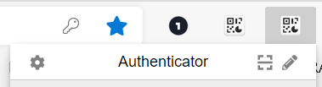

Figure 2.17

- The user will then use the authenticator app to scan the QR code or manually enter the key. A message will be displayed upon successful addition of the Username to the authenticator in the user’s browser (Figure 2.18).

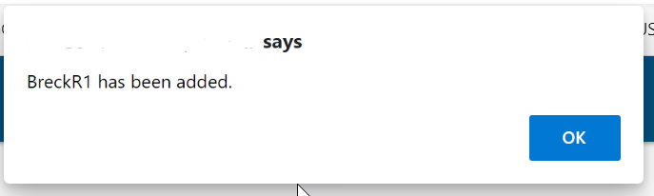
Figure 2.18

- The user will then select the authenticator and enter the code generated by the authenticator in the Verification Code field on the MFA screen and click Submit (Figure 2.19).

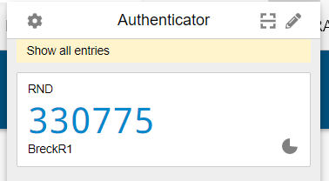
Figure 2.19

After successfully entering the Verification Code, the user will be logged into the system and the registration is complete (Figure 2.20).

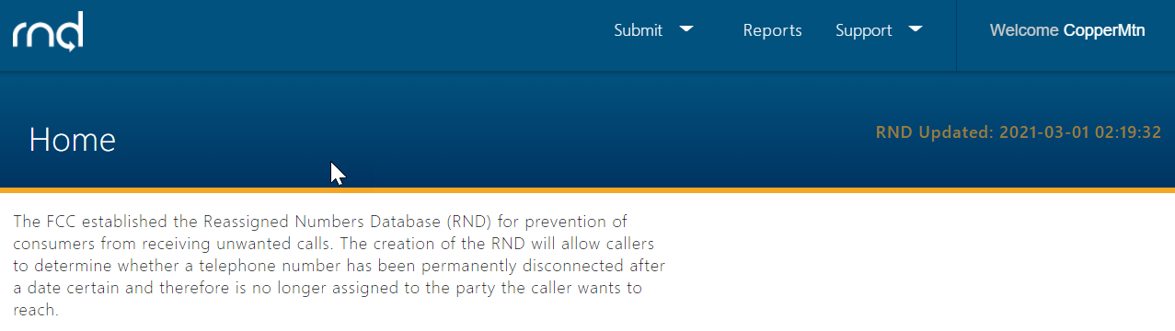
Figure 2.20

The RND provides the ability to view your profile information. You can edit your Title, Work and Secondary Phone numbers. Edits to Name and Email require assistance from RND Customer Support.

To review Profile information
- Navigate to Welcome, Profile (Figure 2.21)

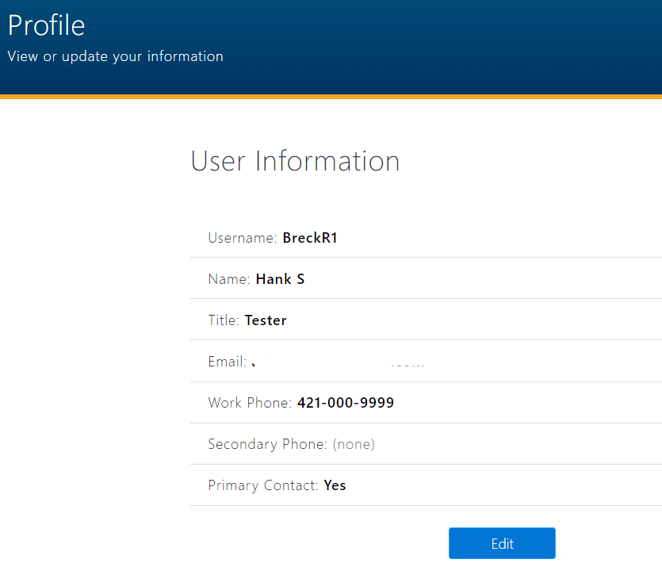
Figure 2.21

- Click Edit, to edit information (Figure 2.22)
  - The user can edit the following:
    - Title.
    - Work Phone, Extension, Text-Enabled.
    - Secondary Phone, Text-Enabled.
  - Click Save or Cancel

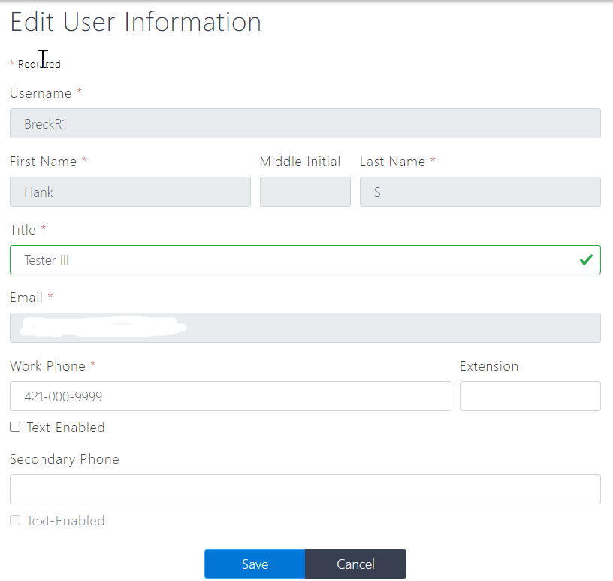
Figure 2.22

The user can log out of the system by selecting their Username and Logout (Figure 2.23):

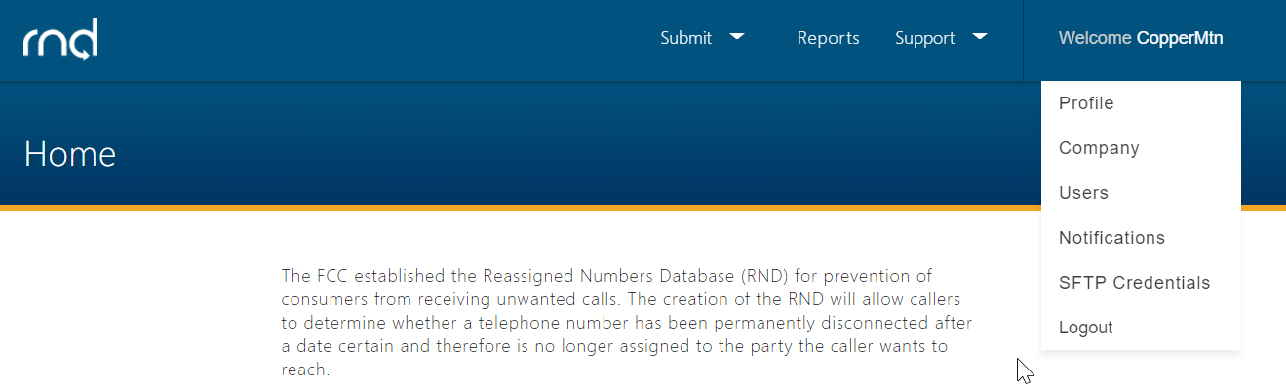
Figure 2.23

To log back into the system, the user will return to the RND website, and re-enter their Username and Password after which the user will then be required to enter a Verification Code. This can be done by selecting the authenticator, copying the displayed code, and selecting Verify (Figure 2.24).

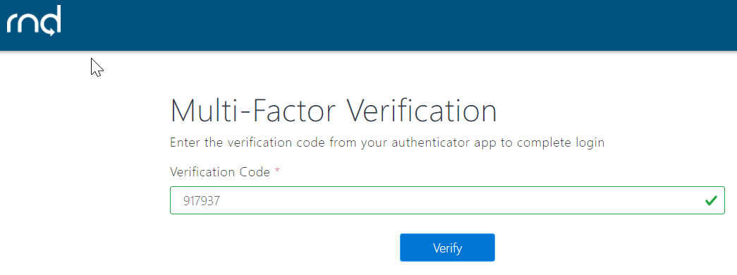
Figure 2.24

3.0. Adding Additional Users to a Company
The Primary Contact can register additional user(s) of the RND for their company. By completing the registration, the Primary Contact is authorizing the additional user(s) to have access to the RND.
To invite an additional user to the company after logging into the system:
- Navigate to Welcome [Company ID].
- Select Users and an option to Invite User will appear (Figure 3.1)

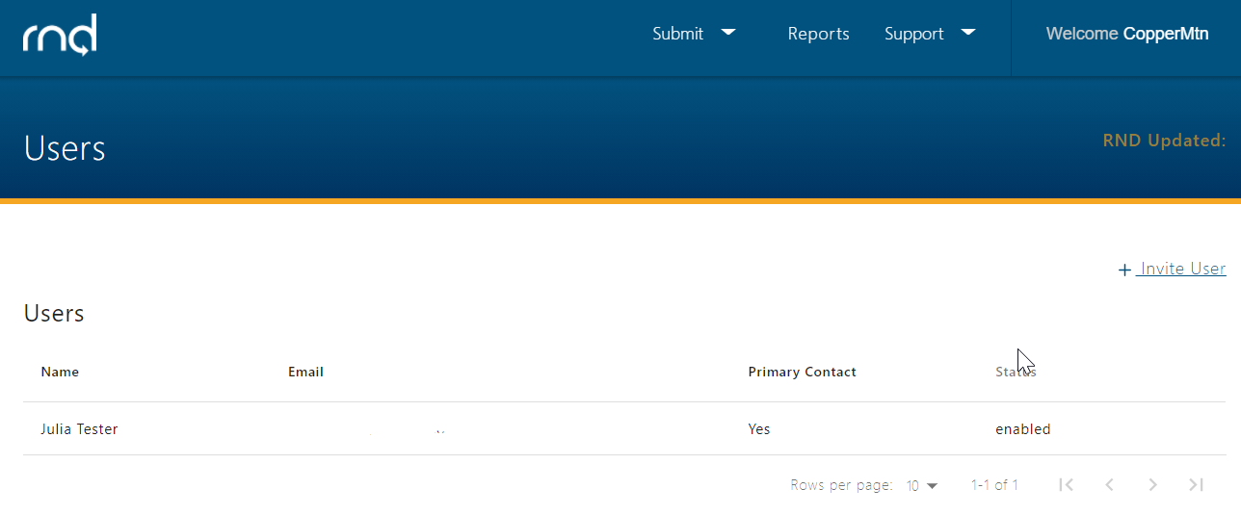
Figure 3.1

- After selecting Invite User, enter the applicable User Information (Figure 3.2):

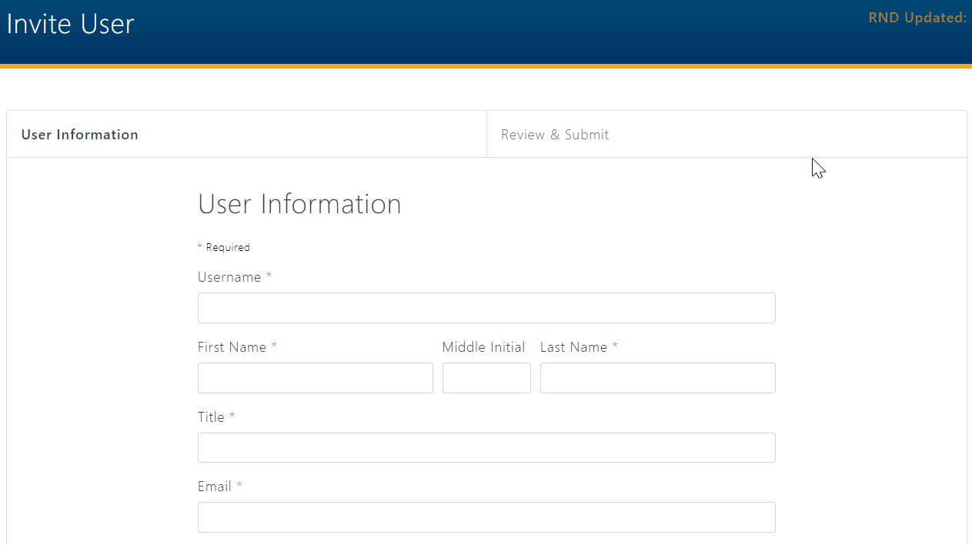
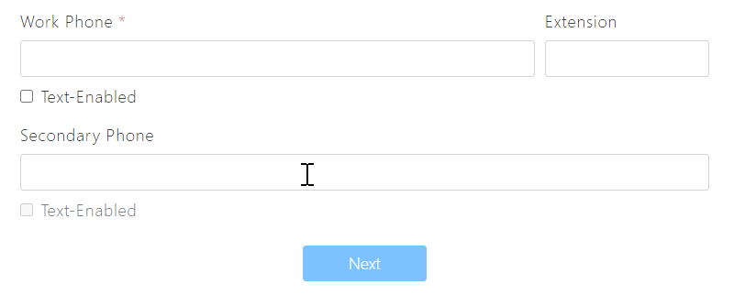
Figure 3.2

  - Username
    - Minimum of 6 characters, maximum of 25 characters.
    - Letters and numbers are accepted.
    - Special characters including exclamation point “!”, pound “#”, dollar “$”, caret “^”, asterisk “*”, underscore “_” , hyphen “-“, period “.” and “`” grave accent (backtick) are accepted.
    - Must be unique in the system.
  - First Name, Middle Initial, Last Name.
  - Title.
  - Email – must be unique in the system.
  - Work Phone including optional Extension and Text-Enabled setting.
  - Secondary Phone including optional Text-Enabled setting.

After selecting Next, the user will have the ability to Send Invite (Figure 3.3).

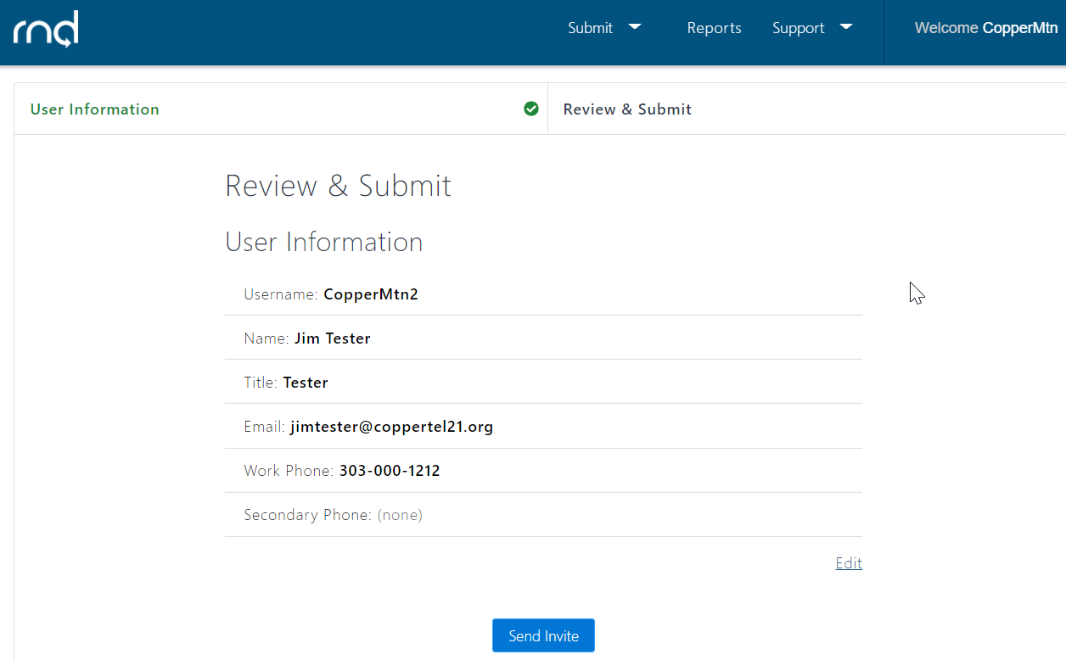
Figure 3.3

The Primary Contact will be notified of a successful invitation (Figure 3.4). The Primary Contact should notify the additional user of the Username that the Primary Contact selected for the additional user.

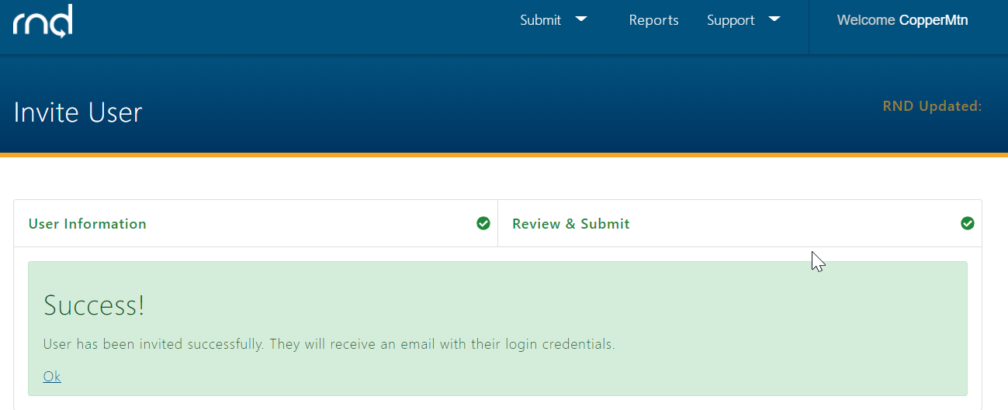
Figure 3.4

The additional user will be sent an email notifying the additional user of the ability to log into RND (Figure 3.5).

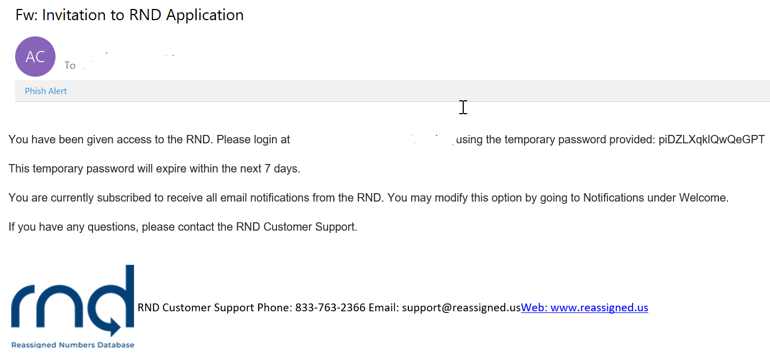
Figure 3.5

After entering the Username and temporary password, the additional user will be required to change their password and set up MFA for their new Username as described previously for a Primary Contact (see Section 2, step 7, Login).

4.0. Adding Client Companies – Service Provider Agents
An SPA can add Client companies to their profile after logging into the RND:
- Select Welcome [Company ID], then Company.
- Page down on the screen and select “+ add new client company” (Figure 4.1).

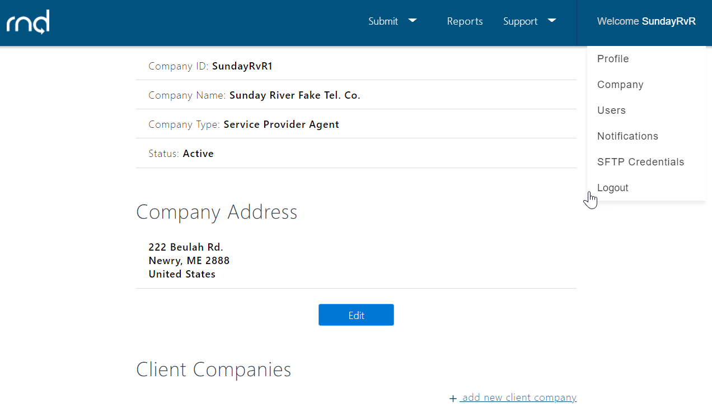
Figure 4.1

- Client Company Information – enter the following information (Figure 4.2)
  - Company Identifier
    - Company ID of the Client company.
    - Minimum 3 characters, maximum 10 characters.
    - Alphabet and numbers.
  - Client Company Name

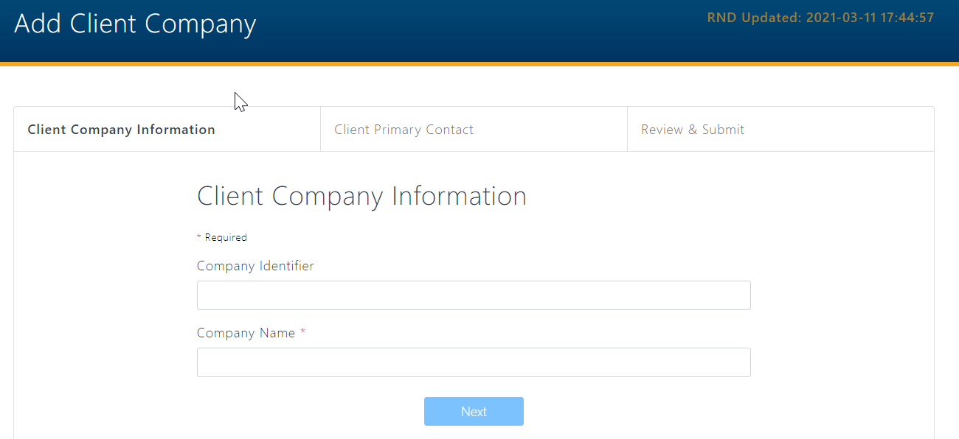
Figure 4.2

- Client Primary Contact – enter the following information (Figure 4.3)
  - Name – including First Name, Middle Initial, Last Name.
  - Title.
  - Email.
  - Work Phone including optional Extension and Text-Enabled setting.
  - Secondary Phone and optional Text-Enabled setting.

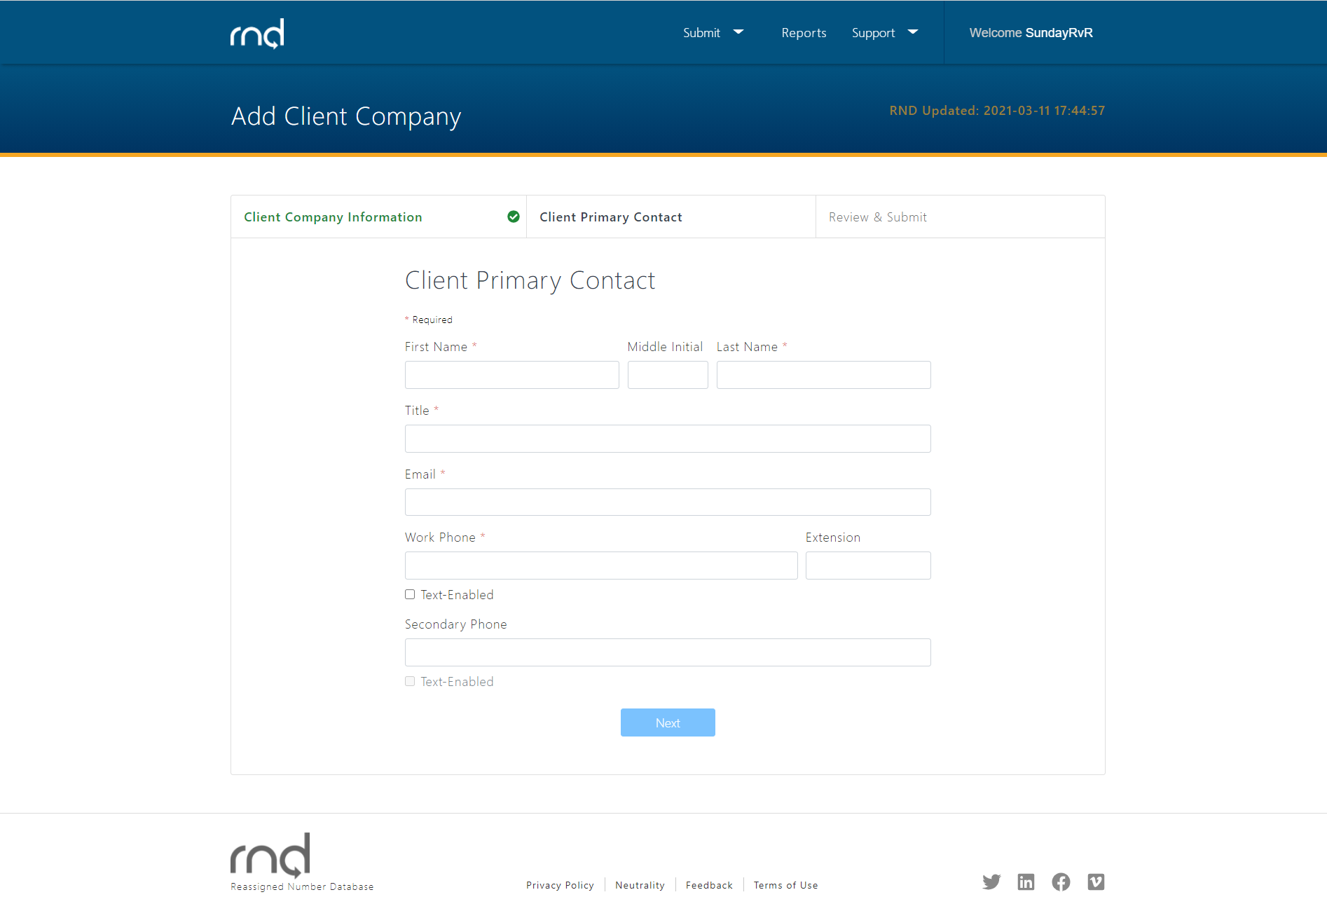
Figure 4.3

- Review & Submit
  - Review information entered (Figure 4.4).
  - Click Edit to modify any information.
  - Click Add Client Company to complete your request.

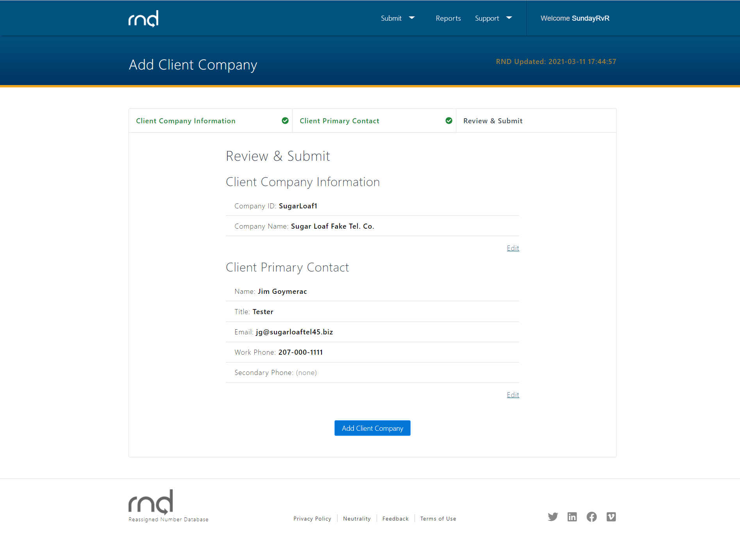
Figure 4.4

After selecting Add Client Company, the user will a notice of successful submission (Figure 4.5).

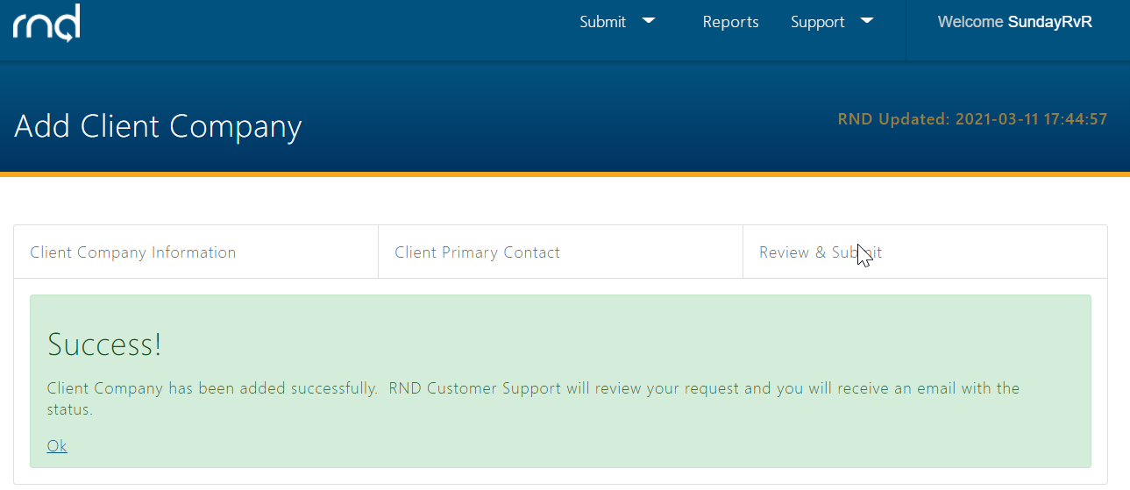
Figure 4.5

Addition of the Client company requires RNDA approval. Prior to approval, the SPA can review the addition in pending status by selecting Welcome, then Company (Figure 4.6).

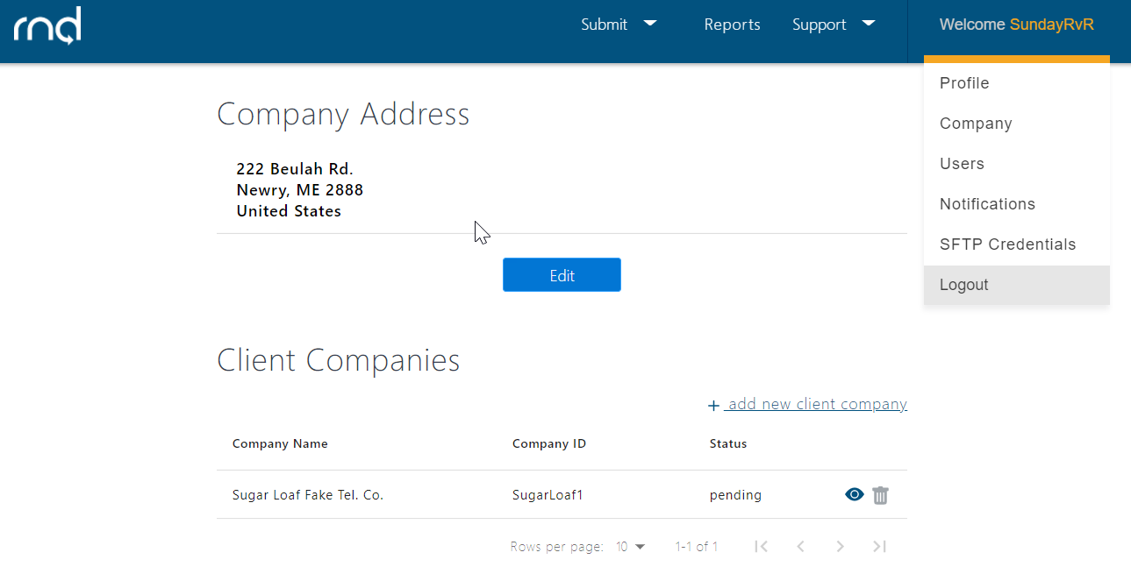
Figure 4.6

Once approved, the SPA will receive confirmation of the addition by email (Figure 4.7).

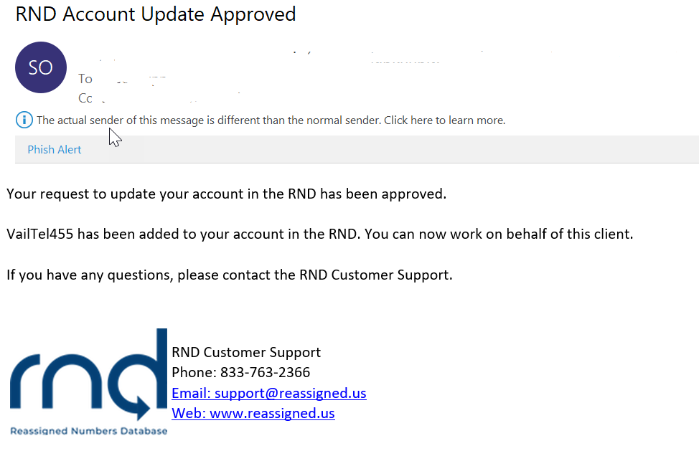
Figure 4.7

The SPA can then check that the addition is in active status by returning to the Company selection under Welcome (Figure 4.8).

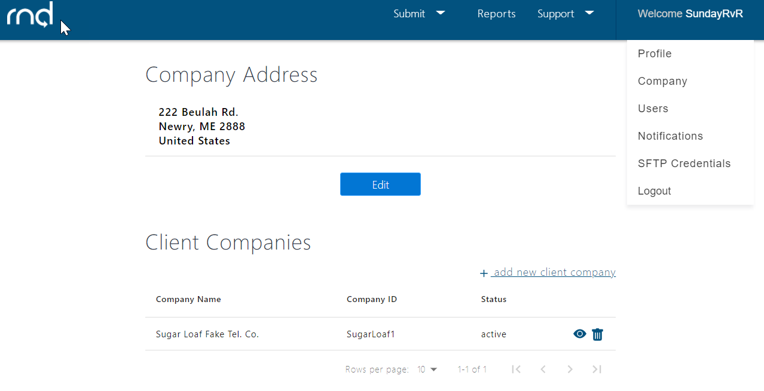
Figure 4.8

5.0 Notifications
Upon registration, SP and SPA users are automatically opted-in to receiving RND email notifications on these subjects:
- System Availability: Scheduled system maintenance and system availability issues.
- User Education: Updated forms, instructions and system user guides, new tools, system changes, personnel announcements, changes to RNDA processes, new items on the RND website, system user education opportunities.
- Database Updates: Notification of the availability of updated reassigned number database.
- Data Submission: INC guideline changes, data submission schedule/reminders, tips for data submission; other general information directed to data submitters.
To view and update email notification settings after logging into the RND system:
- Navigate to Welcome, Notifications (Figure 5.1)

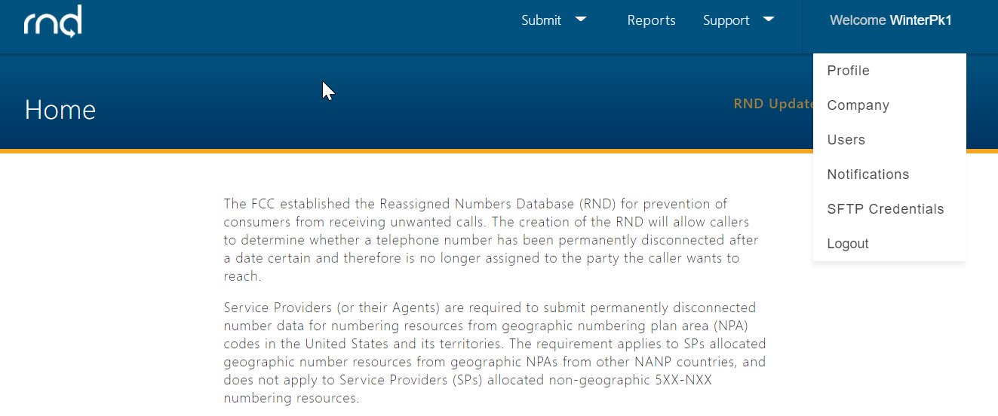
Figure 5.1

- To update notification settings:
  - Select Edit (Figure 5.2).

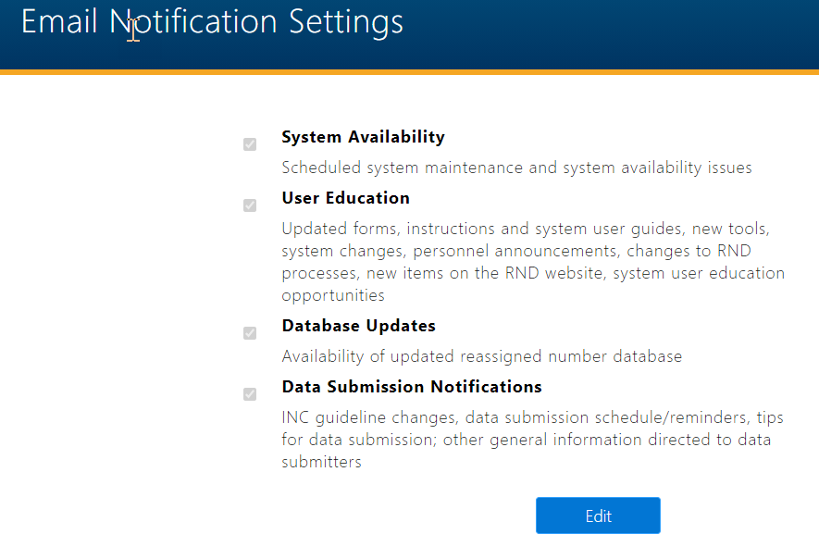
Figure 5.2

  - After modifying notification subscriptions, select Save (Figure 5.3).

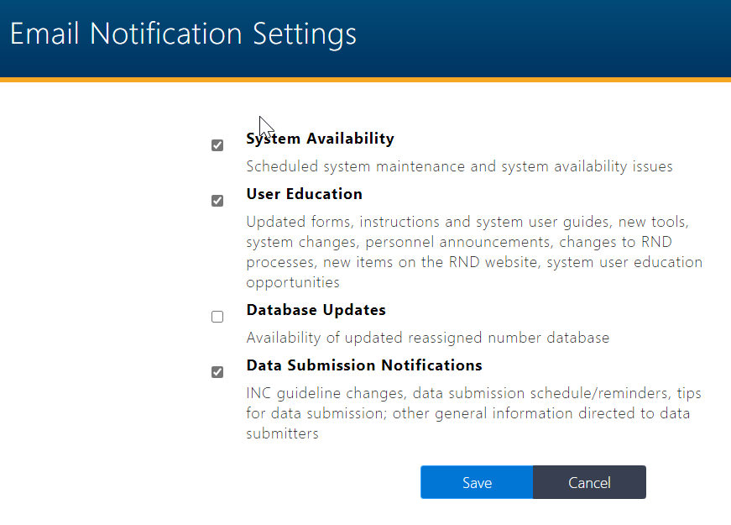
Figure 5.3

6.0 Exception Messages
The following section describes various exceptions or error messages the user may encounter when registering for the RND.
The following are common validation error messages the user might receive while completing Steps 1-5 of the registration process:
The user must select a unique Username and the system will alert the user that the user should select a different one:

Username already exists.
The Company ID is unavailable.
Please enter a different company ID to proceed or contact the Help Desk Admin.

The following are common validation error messages that you might receive while completing Steps 6-7 of the registration process.
- After setting up MFA, if the user enters an incorrect validation code from the authenticator, the user may receive this error:
The code you have entered is not valid.
The user should enter a current and valid code from authenticator.

- If after logging in, the user wishes to edit the user’s Work Phone but does not list one, the user will receive this error:
Work Phone is required.
The user should list a work phone number in the required format (e.g., 555-303-4000).

7.0 Acronym List

Company ID – Company Identifier
ET – Eastern Time
INC – Industry Numbering Committee
NANPA – North American Number Plan Administrator
RND – Reassigned Numbers Database
RNDA – Reassigned Numbers Database Administrator
SP – Service Provider
SPA – Service Provider Agent
TN – Telephone Number
VoIP – Voice over Internet Protocol
YYYY-MM-DD – Year-Month-Day

