Data Submit User Guide

For the Reassigned Numbers Database

Version 1.2
April 12, 2021

Change History
Date | Revision | Change
03/22/2021 | 1.0 | Initial User Guide
03/26/2021 | 1.1 | Cutoff date monthly filings (Sec. 3)
04/12/2021 | 1.2 | No need to resubmit for duplicate (Sec. 4.1)

Table of Contents
1.0 Introduction 3
1.1 Purpose 3
1.2 Overview 3
1.3 System Settings 3
1.4 Assistance 3
2.0 Initial Seed Data 4
3.0 Monthly TN Report File Submissions 4
3.1 TN Report File Format 4
3.2 TN Report File Format for submissions over 1 million rows 7
3.3 Submit TN Report 8
3.3.1 Submit TN Report by File Upload in the GUI 8
3.3.2 No Disconnect TNs to Report for a Monthly Period 9
3.3.3 Submit TN Report File by SFTP not implemented yet 10
3.3.4 Confirmation of File Received 10
4.0 TN Report File Processing 11
4.1 Email Confirmation of File Processed 11
5.0 RND Update 12
6.0 Submitter Reports 12
6.1 Telephone Number Data Report 12
6.2 TN Submission Report 14
6.3 Result Files for Download 16
7.0 Update TNs after 15th of the Month - under development 17
7.1 Update TN Fix File format 17
7.2 Email Notification of Processing—Coming Soon 18
8.0. Acronym 19

1.0 Introduction

1.1 Purpose
This document provides instructions for Service Provider or Service Provider Agents to submit permanently disconnected telephone number data and run reports.

1.2 Overview
This is a brief overview of the information contained in this document; additional details are provided in separate sections of this document.
The Reassigned Number Database (RND) system securely houses permanently disconnected US geographic and toll-free numbers and the most recent permanent disconnection of each of those numbers. RND supports submitting permanently disconnected telephone numbers and querying the RND database. To gain access to the RND and submit telephone numbers (TNs), you must be a registered user with the type of Service Provider (SP) or Service Provider Agent (SPA).
SPs will submit seed data to initially populate the RND. This data can be submitted with multiple files for each Company ID. After the initial seed data, SPs are required to provide a monthly TN report due by the 15th of each month before midnight EST. If a SP chooses to use a SPA, then the SPA will submit the monthly TN report on behalf of the SP. The latest file submitted for each SP Company ID will be processed.
The SPs or SPAs are required to create a TN monthly report in the defined file format. This data will be submitted by file upload in the GUI or SFTP. Once received, the monthly TN report will be processed into staging where the data will be validated. Notifications of data received, and validation will be provided based on submission method. After midnight on the 15th of the month ET, all the monthly TN report data will be processed into the RND.
If an error is discovered after the 15th of the month, the RND Customer Support is available to provide emergency fixes to TNs in order to add, modify or remove them from the RND.
SPs and SPAs will be able to run reports on their monthly TN reports submitted and their TN data in production RND.

1.3 System Settings
The RND uses the following standard datetime format MM/DD/YYYY HH:MM:SS in Eastern Time for display and download data. Example 12/19/2020 14:35:22.
When editing data in the RND, a red Asterix (*) will appear next to required fields.

1.4 Assistance
If you have any questions or issues, please contact the RND Customer Support at 833-763-2366 or support@reassigned.us
The RND will be available between 8:00 am and 8:00 pm Monday through Friday EST, excluding the recognized holidays which will be publicized on https://www.reassigned.us when the website is operational.
On the 15th day of each month, the RND shall be available from 8:00 am until midnight EST to allow for full support of the monthly update. This is true even if the 15th occurs on a weekend or a holiday.

2.0 Initial Seed Data
Initially, the SPs and SPAs will populate the RND with seed data. This data can be submitted with multiple files for each Company ID. This will be submitted using either File Upload in the GUI and use the TN Report File Format as described in detail below.

Smaller Service Providers have until the 10/15/21 deadline to submit their initial seed data.

3.0 Monthly TN Report File Submissions
To be in compliance, each SP is required to provide a monthly TN report due by the 15th of each month before midnight ET, even if the 15th falls on a weekend or holiday. While the data should be as current as possible, not all service providers will be able to report numbers disconnected through the 15th of the month by the 15th of the month. The cutoff date for the data in the monthly file should include disconnects at least through the 10th of the month. If there are disconnects that occur after the 10th of the month, it is acceptable for those disconnects to be included in the next monthly report. Any number that is permanently disconnected after the cutoff for the monthly file should be included in the following month’s file.
If an SP chooses to use an SPA, then the SPA will submit the monthly TN report on behalf of the SP. The SP is responsible for the timely submission of the TN report, even if it uses an SPA.
The file should contain permanently disconnected TN data since the last report submitted for one RND- registered SP company ID. The RND will contain the latest file submitted for each SP Company ID by midnight on the 15th ET to update the RND. For example, if the SP provides a file with 5000 TNs on the 13th of the month, but realizes it has an additional 50 to provide, they must resubmit a file with all the TNs, 5050, to be processed. The RND will process the latest file submitted. If the SP has over one million rows of data to report and is using the BatchID process, only the specific file in question will be replaced.

3.1 TN Report File Format
This format is valid for both initial seed data and monthly TN report submissions as well as both methods of submission including file upload in the GUI and SFTP.
SPs and SPAs will prepare a file in CSV or XLXS data format with a row for each TN and last date of permanent disconnection with their allocated and ported-in numbers. Each TN Monthly report file is limited to 1 million rows. An SP needing to submit more than 1 million rows of data can use the insertion of the “BatchID” on Row 2 of the file. Please see Section below for BatchID file format to submit multiple files.
The company ID contained in the file must be registered in the RND in an Active status and associated with the user submitting the file in order for the RND to process the data. For Service Provider Agents, the company ID must be a Client in Active status associated with your Service Provider Agent company in order to process the data. Service Provider Agents may not use their Company ID to upload data. You can see a list of company IDs associated with your user by going to Welcome, Company or see Profile User Guide for additional details.

File format information:
- File Name
  - User can pick file name, no limitations except for length of XXX
- CompanyID - required
  - Must be the first row
  - Must only be one
  - The value is required to be registered in the RNDA prior to using
  - Must be in an active status
  - Must be associated with the user uploading the file
- Additional Information – optional
  - The user may provide additional data for their own purposes, such as Reporting Period or Internal tracking number. The system will ignore this information.
  - Additional Contacts may be provided in a row which will be used to send notifications for this submission.
    - You may include up to 5 additional Contact email addresses. It is recommended to use distribution list if more than 5 are needed.
    - Will be courtesy copied (cc’d) on the confirmation email that system has processed the file and resulting errors
    - If more than 5 email addresses are supplied, then the first 5 will be included and the rest will be ignored by the system
    - If more than one row of additional contacts is supplied in the file, the last row will be processed with the first 5 email addresses cc’d on the email.
- Telephone Number List – required
  - Row must exist and will alert the system to start processing disconnected telephone numbers
  - TN format - valid formats
    - ########## (example: 2025550100)
    - Must be 10 digits
    - NPA must be 200 or greater
    - NXX must be 200 or greater
  - Date format - valid formats
    - YYYY-MM-DD – 2020-05-01
    - MM/DD/YY - 05/01/20
    - MM/DD/YYYY - 05/01/2020
    - M/D/YY - 5/1/20
    - M/D/YYYY - 5/1/2020
The file at a minimum must contain these rows in this order:
- CompanyID
- Telephone Number List
- Telephone, Date
For XLXS – the first worksheet will be processed. Any data in additional worksheets will not be processed.
Example File Formats
CSV File Format
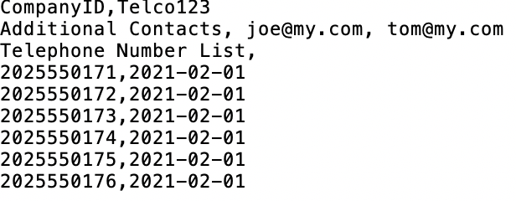
xlsx Format
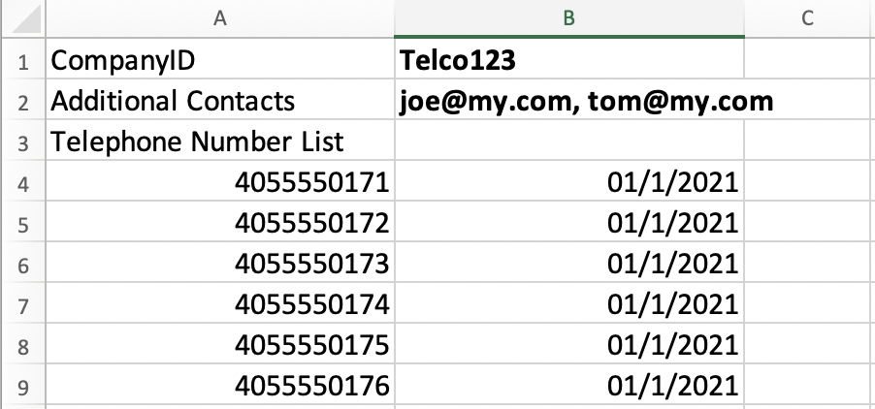

3.2 TN Report File Format for submissions over 1 million rows
An SP needing to submit more than 1 million rows of data can use the insertion of the “BatchID” on Row 2 of each of the files submitted for the monthly submission. Please use the following BatchID file formats shown below to submit multiple files.
Example File Formats with BatchID
CSV File Format
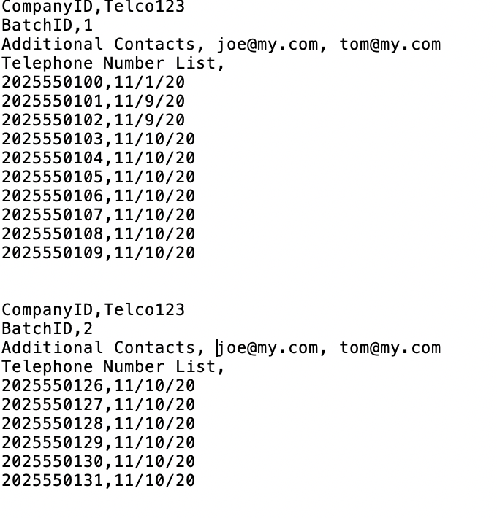

xlsx Format
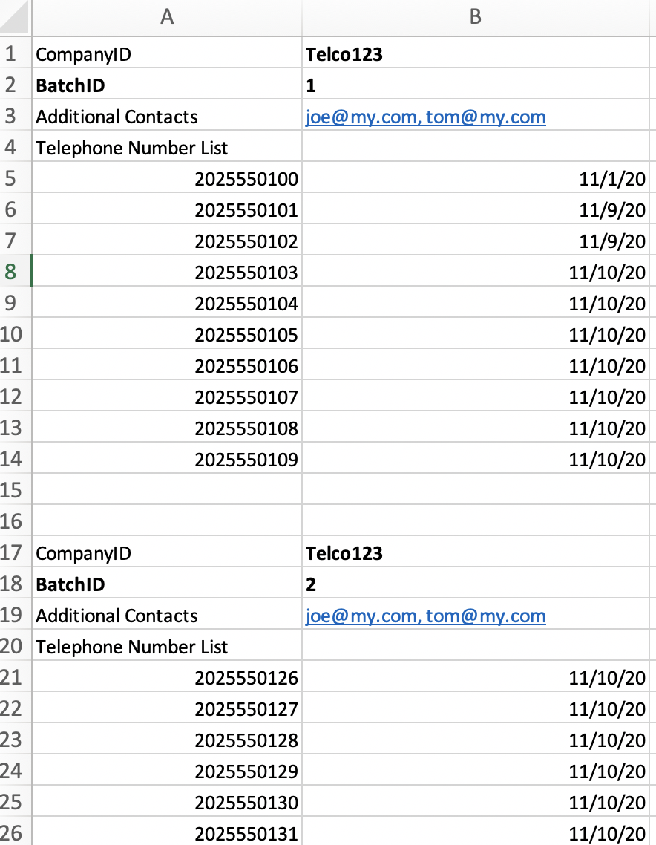

3.3 Submit TN Report
These methods can be used for the initial “seed” data as well as the monthly submission. The file format is the same for both methods, as outlined above.

3.3.1 Submit TN Report by File Upload in the GUI
In order to submit the monthly TN report by file upload in the GUI, the user must be a registered user. A file must be created according to the information provided above.
Submit Report by File Upload
- Login to System at https://www.reassigned.us
- Navigate to Submit, TN Disconnect Upload
- To select a file to upload hit “Choose File”
  - Files must be .csv or .xlsx format
- The system will confirm successfully upload on the screen
- You will receive an email notification when the file is processed, and any additional contacts will be courtesy copied on the email
- Please see TN Report File Processing section for details on validation errors

3.3.2 No Disconnect TNs to Report for a Monthly Period
If there are no permanently disconnected TNs to report for a monthly period, the user must report no disconnected telephone numbers using the Web GUI in order to be in compliance. If you report No data to submit, but then determine you do have data to submit before midnight on the 15th, the latest data submitted will be processed to the RND.

- Navigate to Submit, TN Disconnect Upload
- In the section “Report No Disconnect Data”
  - Select Company ID
  - Hit Submit
- You will receive confirmation on the screen for successful submission

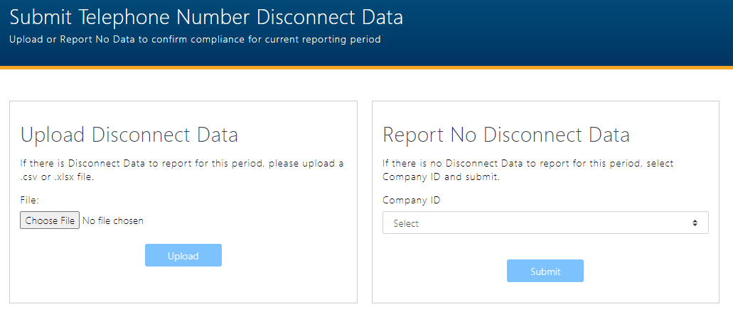

3.3.3 Submit TN Report File by SFTP not implemented yet
Monthly TN reports can be submitted via SFTP, and the Primary Contact has the authority to create the SFTP Account.
The file format for SFTP is the same for both methods as outlined above under the TN Report File Format section, above.
In order to set up the SFTP account, the Primary Contact will:
- Login to Login to System at https://www.reassigned.us
- Navigate to Welcome / SFTP Credentials
- The info tooltip/popup will provide a link for basic information regarding SFTP
- After agreeing to the Terms of Use, the user will be presented with a text box in which the user will Upload their SSH Public Key
- After uploading, the user will be presented with the success message: SSH Public Key uploaded successfully

The Primary Contact will be notified via email when the SFTP Credentials are expiring in order to upload a new SSH Public Key to update the SFTP Credentials.

3.3.4 Confirmation of File Received
If submitting file by File Upload in the GUI, you will receive a message on the screen of a file successfully submitted, as well as email confirmation of successful or unsuccessful data transmission of report and/or update files.
If submitting file by SFTP, you will be sent an email confirmation of successful or unsuccessful data transmission of report and/or update files, and successful database update.

4.0 TN Report File Processing
The RND will process the TN Report file after it is uploaded. All valid data will be processed into staging table which will then be processed after the 15th at midnight. A Confirmation of File Processing will be sent to the user who submitted with file and additional contacts included in the TN Report File along with information on total entries processed and total validation errors.
- TN format
  - Valid is 10 numeric digits ##########
  - Invalid:
    - TN less that 10 digits – examples 411, 911, 703453
    - TN that is not numeric – example 7034532XXX
    - TN Area Code (NPA) less that 200 – example 1991234456
    - TN Central Office (NXX) that is less that 200 – example 2021898877 or 7031772424
  - Duplicate TNs in a file,
    - If the disconnect dates are the different than the one with the latest disconnect date will be processed to staging
    - If the disconnect dates are the same, then the first one will be processed into staging and the second one will be flagged as a validation error and included in the confirmation email back to the user who submitted the file
- Date Format
  - Valid if YYYY-MM-DD, MM/DD/YY, MM/DD/YYYY, M/D/YY or MM/DD/YYYY
  - Invalid date format
    - DD/MM/YY - If DD/MM/YY is used, the system will interpret as MM/DD/YY and will result in inaccurate date
    - Date is in future – example: 2100-12-01
    - Date is earlier than 1/1/2001 - example 1/1/2000

4.1 Email Confirmation of File Processed
Once the file is submitted, the RND will process the file and you will receive an email confirmation. See TN Report File Processing section for details. These are the following situations that are included in the confirmation email:
- File processed successfully and no validation errors
- File processed successfully with validation error(s) of “Duplicate TN / Date pair, skipped: 2025550222 2021-02-24 – there is no need to resubmit; the RND will input the TN with the latest disconnect date
- File processed successfully but found validation errors – please review, fix and resubmit file
- File was rejected so that no data was processed and needs to be review, fix and resubmit; this can happen if
  - The Company ID is not provided in the file
  - The uploading Company ID is not active
  - The Company ID in the file is not active or doesn’t exist in the RNDA
  - The Company ID is not associated with the user
    - Service Provider Agents did not provide Company ID of Client
  - Service Provider Agent used their own company ID, must use Company ID of Client
  - Multiple company IDs were provided in the file
Example of validation errors in email attachment
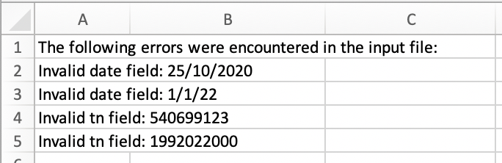

Example of duplicates – TNs reported in same file with more than one disconnect date
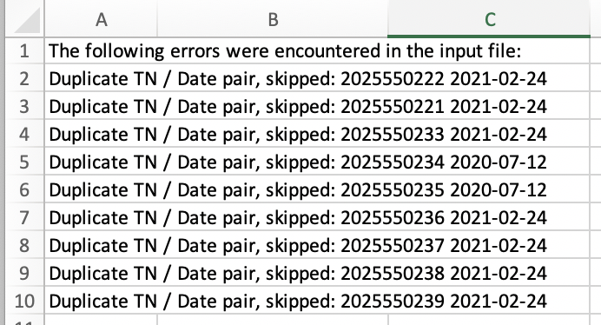

5.0 RND Update
The RND will process the disconnected TN data no later than 8am EST on the second calendar day. The Dashboard will be updated, and an email sent to all users subscribed to the “System Availability” notifications.

6.0 Submitter Reports

6.1 Telephone Number Data Report
You will be able to pull a report of data in the RND associated with your Company ID.
- Navigate to Submit / Query TN Data
- In the search criteria,
- Telephone Number - you must enter telephone number information. The options include
  - TN - you can enter a single telephone number using the following format NPA-NXX-XXXX
  - TN Range - use can enter a range of telephone numbers using the following format, from NPA-NXX-XXXX to XXXX
  - NPA – you can enter a single NPA using the following format NPA
  - NPA NXXX(s) - you can enter 1 to 5 using the following format NPA NXX, NPA-NXX, NPA-NXX
- Disconnect Date Range is optional and is limited to 365 days, if you require to run more than 365 days, simply run the query multiple times for the additional days
- Update Date Range is optional and is limited to 365 days, if you require to run more than 365 days, simply run the query multiple times for the additional days
- Company ID is required and only one may be selected
  - This is limited to Company IDs associated with your Login
- Username is optional and is be limited to Usernames associated with your company
- File Type defaults to CSV, but XLSX can be selected as well
- Then click Search
- The Results are automatically downloaded to your computer
  - The same information is included whether CSV or XLSX file format is selected

- The Results include the following information:
  - TN
  - Disconnect Date
  - Date Time Updated
  - Company ID
  - Username

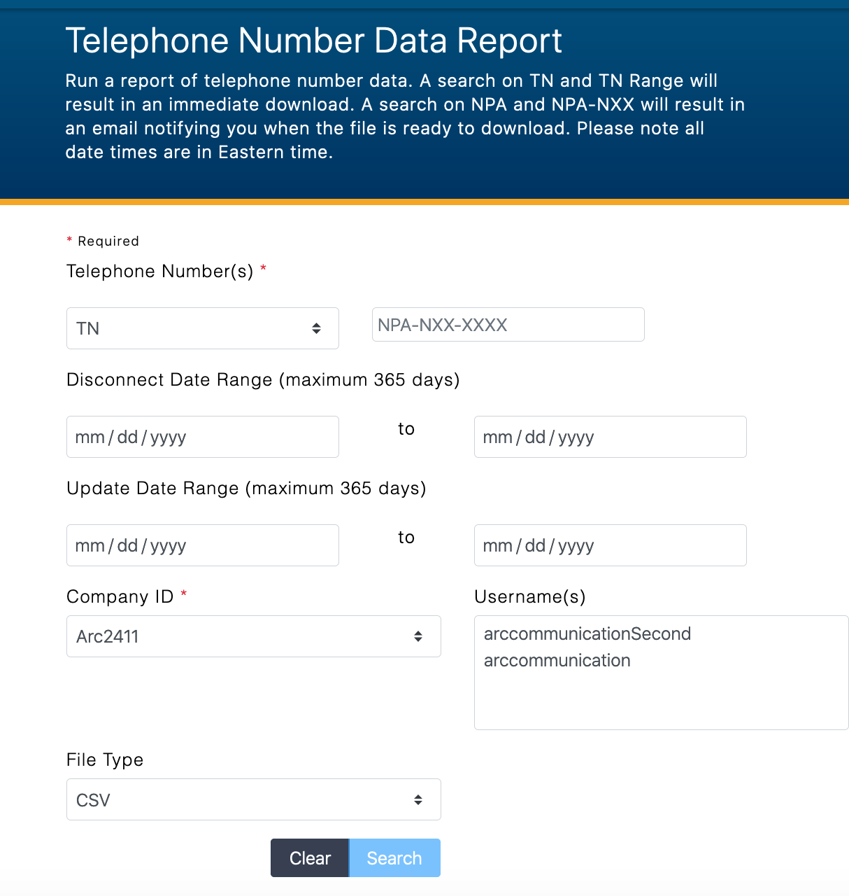

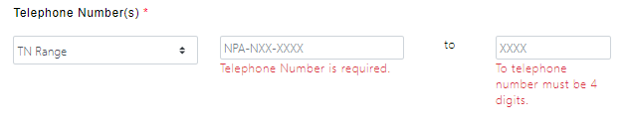
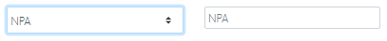
Results in XLSX (Example Data only)
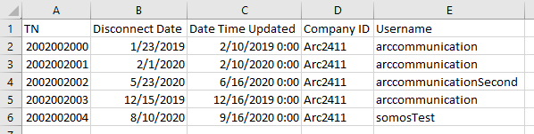

6.2 TN Submission Report
This report will include submissions that have been processed into the RND including Monthly TN Reports, No Disconnect Data, and fixes for a specified Company ID.
- Navigate to Submit / TN Submission Report
- In the search criteria enter the following
  - Date Submitted Range which is limited to 365 days
  - Company ID: you can select one company ID, if you require to run for multiple company IDs, simply run the report for each one
- Select Search
- The results will display in a table
  - Company ID – Service Provider Company ID setup in the upload monthly report
  - Username – username of RND user who uploaded the monthly report
  - Date Submitted – date monthly report was submitted to the RNDA
  - Date Updated - Date with RND was updated with monthly report data
  - Total TNs Successfully Submitted -
    - Monthly Report: Number of TNs submitted with no validation issues when uploaded to the RNDA prior to the 15th of the month.
    - Update TNs:
    - No Data: will be 0
  - Total Exceptions Found -
    - Monthly Report: Number of TNS had an exception error such as a duplicate was found in the same file
    - Update TNs: will be 0; note all validation issues are emailed when file is processed
    - No Data: will be 0
  - If you “Report No Disconnect Data” for a monthly reporting period, a row will display with 0 Total TNs Successfully Submitted, and 0 Total Exceptions Found
  - If you submit an TN Update Fix File though the RNDA Customer Support, a row will display on the report with the date of the fix (not being between the 16 until the RNDA is updated)
  - You are able to download the table
- You are able to download a report for a specific submission on each row of the Results in CSV or XLSX format, which includes the following:
  - Company ID - Service Provider Company ID setup in the upload monthly report
  - Username - username of RNDA user who uploaded the monthly report
  - Date Submitted - Date Time TN submitted to the RNDA
  - Date Updated - Date Time RND was updated with TN data
  - TN - telephone number included in the monthly report
  - Disconnect Date - disconnect date associate with TN
  - Exception Found – exception file, for example the TN was already in the RND but with a more recent date, or if the TN was submitted twice in one file
  - Note: Data included in this file was successfully uploaded to the RNDA. If there were TNs with validation issues, a notification would have been sent to the person who uploaded the file as well as any additional contacts listed in the original upload file.
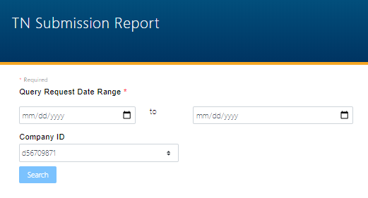
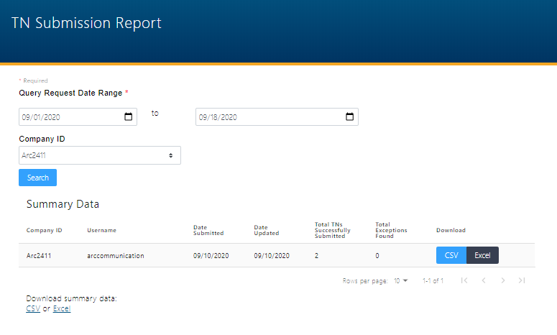
Download for Specific Submission row which the system will create a file and email you when it is ready for download under Submit / Result Files

Sample CSV
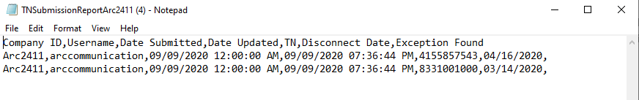
Sample XLSX
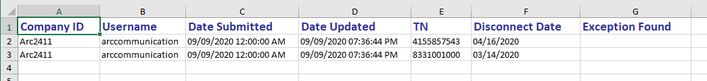

6.3 Result Files for Download
Files created by running reports will be accessible on this page for 45 days. It is recommended that you download a copy of each file for long-term storage. These files are available to any user associated with your company.
- Navigate to Submit / Result Files
- Downloads Displays
  - Username - the user who requested the report
  - Type
    - TN Submission Report Details – this is from Submit / TN Submission Report
    - TN Data Report – this is from Submit / TN Data Report
  - Create Date – date when the report was requested
  - Output Filename – this will include the Report Name and the Company ID specified when running the report
  - Download – the format downloaded will match what was specified when the report was requested.

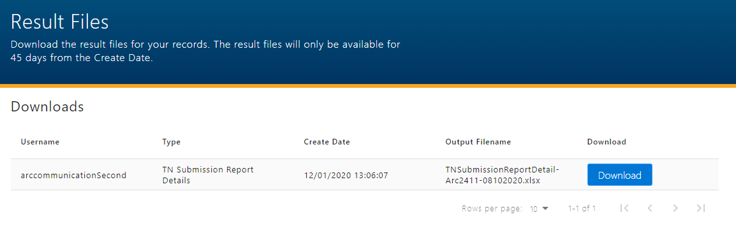

Update TNs after 15th of the Month - under development
If you require updates to TNs after the 15th of the month TN report submission, you will need to prepare a file with only the TNs requiring updates. Through a request to the RND Help Desk, you will be able to Modify or Remove a TN in the RND. For Modify, you may update the TN disconnect date to be before or after the date in the RND but never in the future. For Remove, you may indicate that this TN should not have been previously provided to the RND. The RND will verify that there is no historical data to revert to in the case of a Remove action.

7.1 Update TN Fix File format
The fix file format is the same as the TN Monthly Report except it has an additional column for each TN. You must indicate Modify or Remove for each TN. If you want to receive a copy of the validation email notification, please add an email address to Additional Contacts.
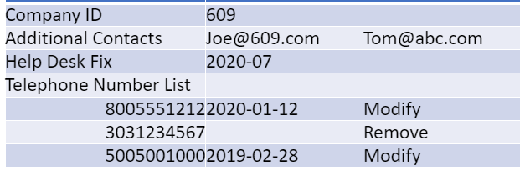
Process:
- Prepare Fix File
  - Add email addresses to Additional Contacts in the File to receive Validation Email Notifications
- Email RNDA Customer Support with the Update TN file
  - In subject indicate URGENT Update TNs
- RNDA Customer Support will review information and contact you with any questions
- RNDA Customer Support will process Update TN File in the system
- If you have added your email address to Additional Contacts, you will receive email notifications from the system
  - Review email for any validation errors that the system detected
  - For Validation Errors
    - Create a New File
    - Include only corrected TNs which had validation errors
    - Submit new file with corrected TNs
- RND will reply to initial email with verification that file has been processed and the RND has been updated

7.2 Email Notification of Processing—Coming Soon

8.0. Acronym
These are terms or acronyms used with in the document.
Company ID – Company Identifier
CSV – Comma Separated Values file format
EST – Eastern Standard Time
GUI – Graphical User Interface
NPA – Number Plan Area
NXX – Central Office (exchange) code
RND – Reassigned Numbers Database
SFTP – Secure File Transfer Protocol
SP – Service Provider
SPA – Service Provider Agent
TN – Telephone Number
YYYY-MM-DD – Year-Month-Day
Xlsx – ExcelTM file format

