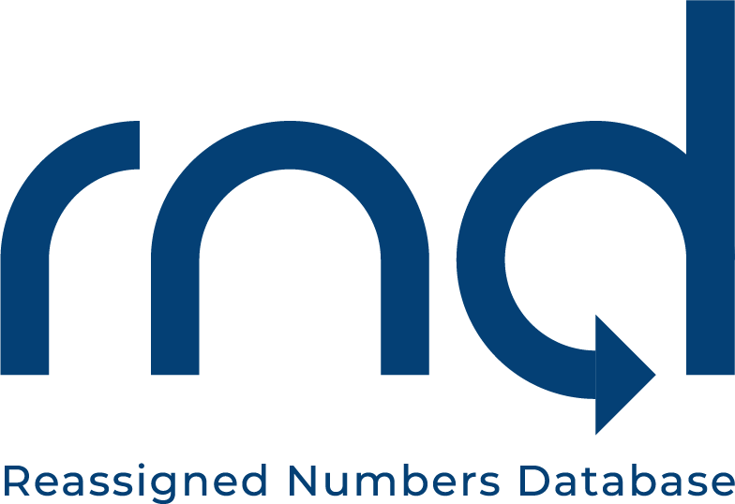

Date: October 25, 2021

Subject: FCC to Host Webinar Upon Launch of Reassigned Numbers Database Nov. 1

Please note the FCC announcement of the November 1, 2021, 2:00pm (Eastern) Webinar to educate callers and caller agents about the Reassigned Numbers Database, which will help prevent a consumer from getting unwanted calls intended for someone who previously held their phone number.

The press release can be found at:
https://www.fcc.gov/document/fcc-host-webinar-upon-launch-reassigned-numbers-database-nov-1.

***

Please let us know if you have any questions. We can be reached at support@reassigned.us, 1-833-763-2366, or https://www.reassigned.us/contact/feedback

